**INFO GATHERING (OSINT)**

**------------------------------------------------------------------------------------**

* **Overview**
  + **Types of Information Gathering**
* **Passive Information Gathering** 
  + - **topics**
    - **Domain & registration info**
    - **DNS (passive Info Gathering)**
    - **Website Reconnaissance**
    - **Google Dorks/Hacking**
    - **User information Recon**
    - **Metadata info Gathering**
    - **Firewall Info Gathering**
    - **Recon Through Open-Source Code**
    - **IOT (devices) search websites**
    - **Recon-ng Framework**
    - **Information Gathering Frameworks**
    - **Extra Notes**
* **SCANNING (Active Reconnaissance)** 
  + **Topic**
  + **Network Tracing**
  + **Network Discover**
  + **Port scanning**
  + **service/Version Scanning**
  + **OS Fingerprinting**
  + **Vulnerability Scanning**
  + **DNS Scanning & Enumeration**
  + **Web application Enumeration**
  + **SSL scanning**

**------------------------------------------------------------------------------------**

* **Overview**
  + **There are 2 types of Information Gathering** 
    - 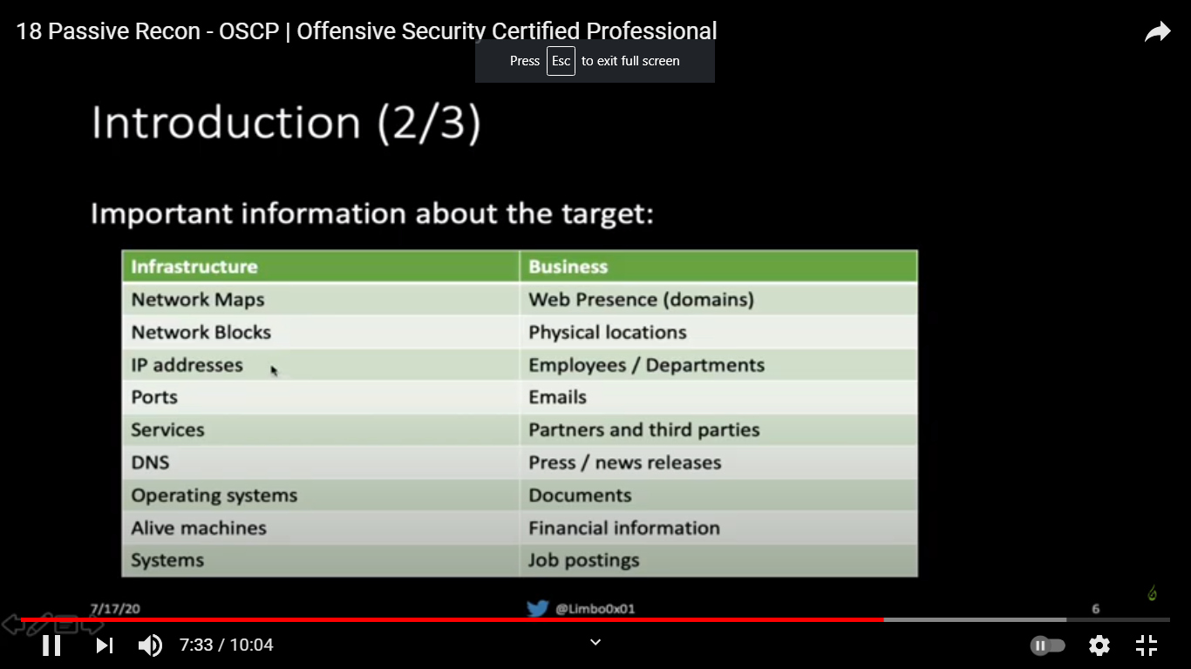
    - **passive Reconnaissance (FootPrinting)**
      * Passive Information Gathering (also known as Open-source Intelligence or OSINT) is the process of **collecting openly available information about a target, generally without any direct interaction with that target**
        + **OSINT: is gathering info on target using public resources**
      * Before we begin, we need to define passive information gathering. There are two different schools of thought on what constitutes “passive” in this context.
        + In the strictest interpretation, we never communicate with the target directly. For example, we could rely on third parties for information, but we wouldn’t access any of the target’s systems or servers. Using this approach maintains a high level of secrecy about our actions and intentions, but can also be cumbersome and may limit our results.
        + In a looser interpretation, we might interact with the target, but only as a normal Internet user would. For example, if the target’s website allows us to register for an account, we could do that. However, we would not test the website for vulnerabilities during this phase.
      * In this module, we will adopt this latter, less rigid interpretation for our approach
    - **Active Reconnaissance (Scanning)**
      * Next, we will move beyond passive information gathering and explore techniques that involve direct interaction with target services
      * “Gather info about the target by being connected to him”
    - 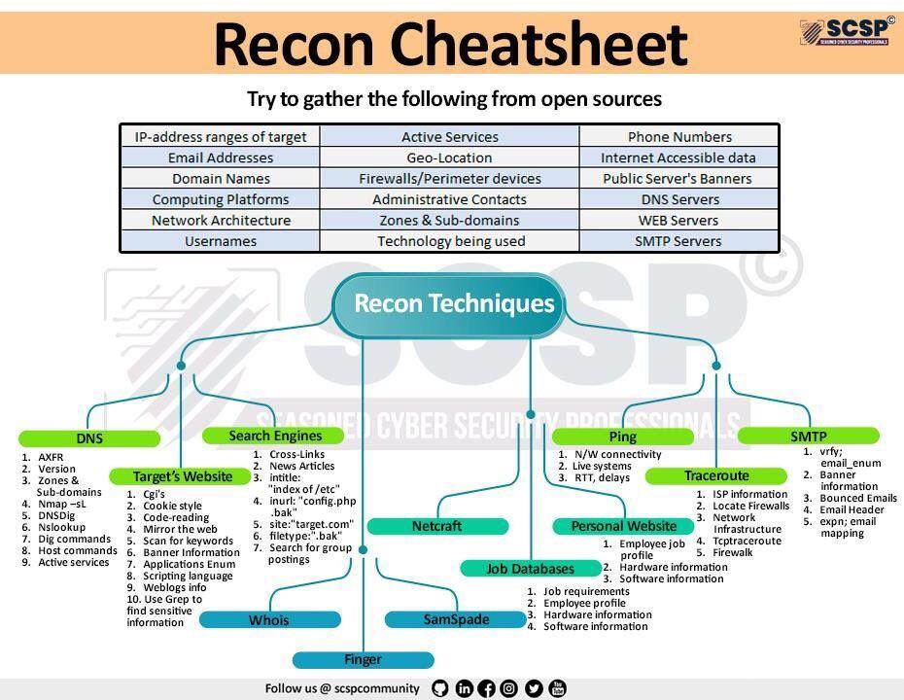
* **Passive Information Gathering** 
  + **Topics**
    - **Domain & registration info**
    - **Dns (passive Info Gathering)**
    - **Website Reconnaissance**
    - **Google Dorks/Hacking**
    - **User information Recon**
    - **Metadata info Gathering**
    - **Firewall Info Gathering**
    - **Recon Through Open-Source Code**
    - **IOT (devices) search websites**
    - **Recon-ng Framework**
    - **Information Gathering Frameworks**
    - **Extra Notes**
  + **Domain & registration info** 
    - The first step to take when assessing a website is to gather information about the organization.
      * **Public info such as**
        + The owner name of the domain
        + Ip address or range
        + Technical contacts
        + Expiration date of the domain
      * **Whois**
        + Whois is a TCP service, tool, and a type of database that can provide information about a domain name, such as the name server and registrar. This information is often public since registrars charge a fee for private registration.
        + WHOIS lookups were traditionally done using a command line interface, but a number of simplified web-based tools now exist for looking up domain ownership details from different databases

**Command Line**

Whois [domain]

**Registrar Information**: info on the company that gave the company its domain name such as namecheap , godaddy , ...etc

Domain Name: DDSEC.XYZ

Registry Domain ID: D204548268-CNIC

Registrar WHOIS Server: whois.namecheap.com

Registrar URL: https://namecheap.com

Updated Date: 2020-10-28T21:51:15.0Z

Creation Date: 2020-10-17T11:34:22.0Z

Registry Expiry Date: 2022-10-17T23:59:59.0Z

Registrar: Namecheap

Registrar IANA ID: 1068

……

**Registrant Information**: info on the person who rent the domain name it can be a person or a company ,...etc

Registrant Organization:

Registrant State/Province:

Registrant Country: EG

Name Server:

……. Etc.

……

Registrant Name:

Registrant Email:

Admin Name:

Admin Email:

Tech Name:

Tech Email:

Whois [ip\_addr]

in addition to this standard forward lookup, which gathers information about a DNS name, the whois client can also perform reverse lookups. Assuming we have an IP address, we can perform a reverse lookup to gather more information about it:

**Web Based**

Who.is

Whois.domaintools.com

Whois.com

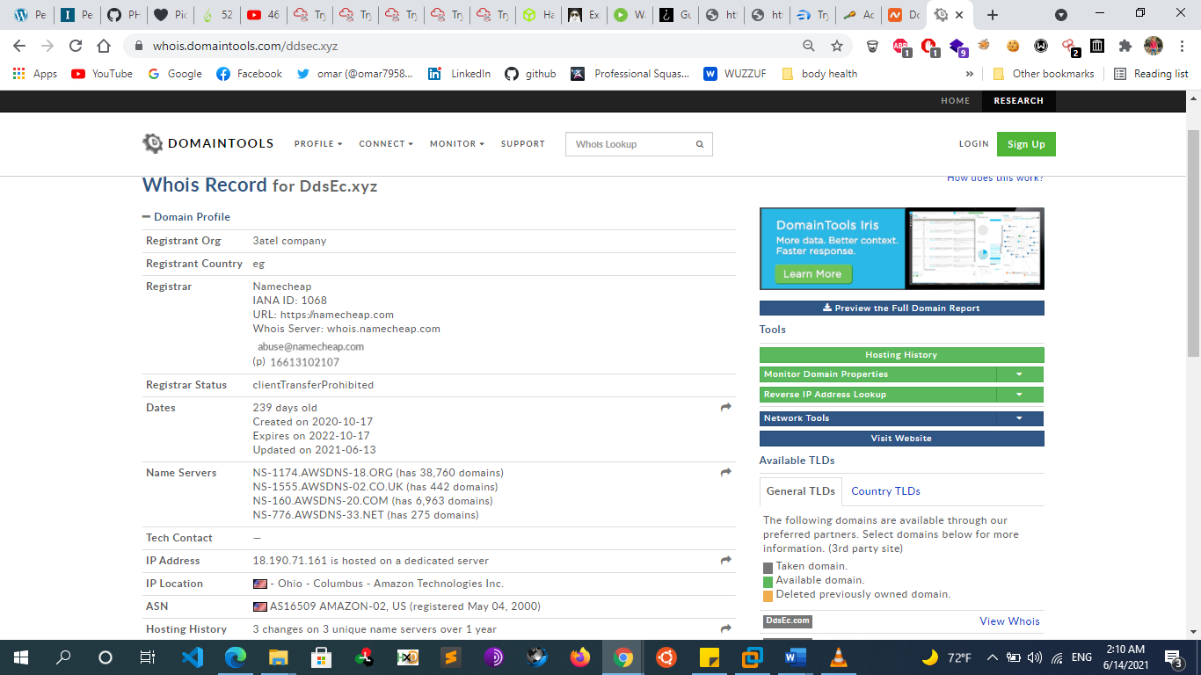

* + - * **Netcraft**
        + Netcraft is an Internet services company based in England offering a free web portal that performs various information gathering functions. The use of services such as those offered by Netcraft is considered a passive technique since we never interact with our target directly.
        + https://News.netcraft.com
        + <https://searchdns.netcraft.com>

For each server found, we can view a “site report” that provides additional information and history about the server by clicking on the file icon next to each site URL

The start of the report covers registration information. However, if we scroll down, we discover various “site technology” entries

* + - * **Lookup.icann.org**
        + 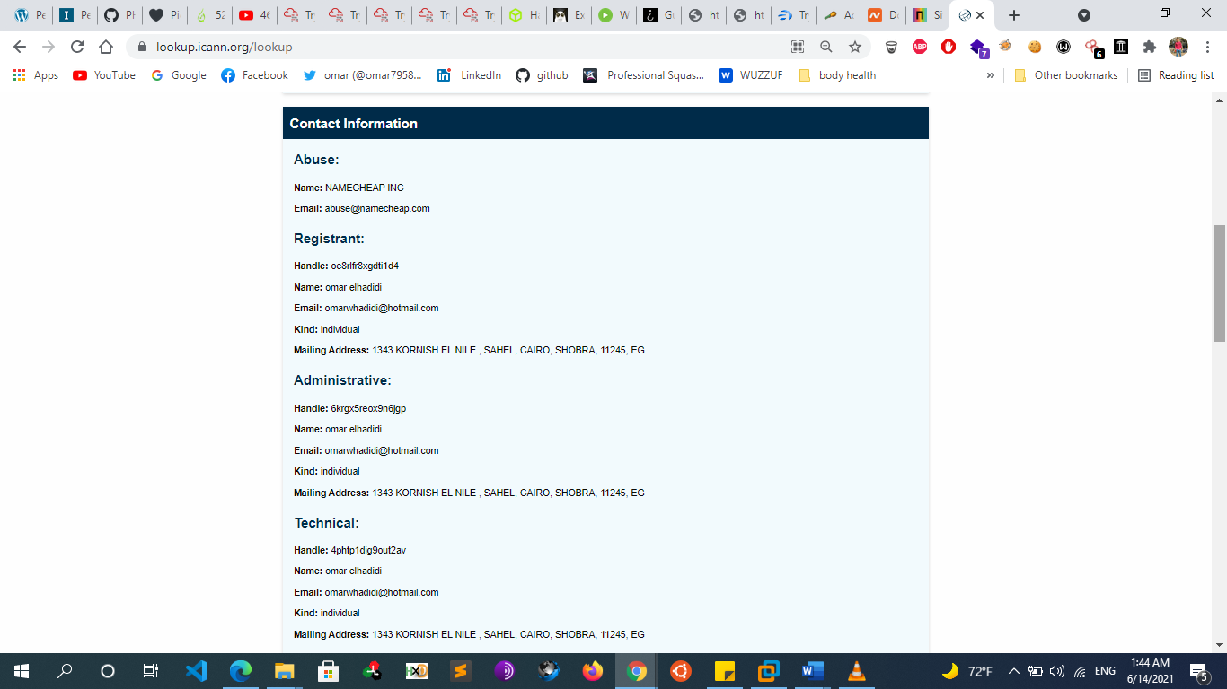
      * 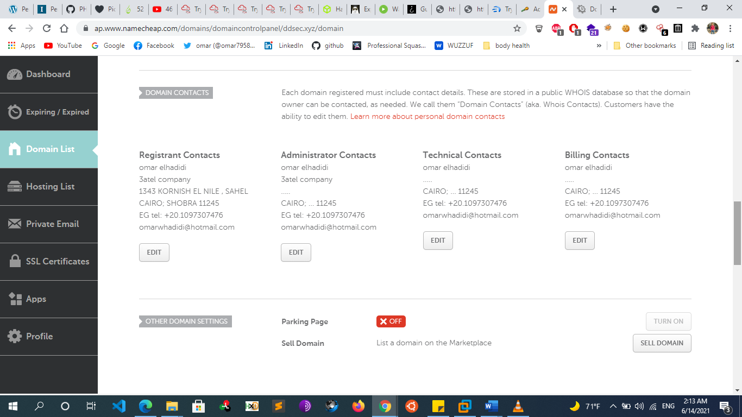
      * **https://viewdns.info/**
        + ViewDNS.info provides a convenient UI for looking up registration information on a target website. ip history , ...Using this information, it may be possible to draw certain conclusions that are not clearly spelled out, such as whether the website is hosted on a shared or dedicated IP address. The answer to this question can imply things about the website's budget as well as traffic
  + **Dns (passive Info Gathering)**
    - Now that we have a bit of valuable information about our target, we can start digging further into the data to start identifying individual targets. A valuable source for such information is the Domain Name System (DNS). We can query it for some of the IP addresses that we received from the WHOIS database.
    - **Dns query websites**
      * Mxtoolbox.com
      * Dnsqueries.com
      * Kloth.net
      * Dnswatch.info
      * Networktools.info
      * Dnsstuff.com
      * Networktools.tom
      * Gsuitetoolbox.com
      * Webmaster-toolkit.com
      * Webbasedtools.com
  + **Website Reconnaissance** 
    - If the client has a website, we can gather basic information by simply browsing the site. Small organizations may only have a single website, while large organizations might have many, including some that are not maintained.
    - **technology used in Websites Info Gathering**
      * **whatweb**
        + whatweb –v [website]
      * **Dmitry**
        + dmitry -winsep [[website]](http://example.com)
        + dmitry -winsepo result.txt [[website]](http://example.com)
      * **Wappalyzer addon**
    - **Archive search & History of the website**
      * website that can help us is archive.org. Here you can simply search a specific domain and then navigate through different date and versions of that specific domain.
      * Similarly, you can use the Google dork cache:URL. With this technique, you will see a cached version of the website.
        + Web.Archive.org
        + Waybackurl script
    - **Firewall Info Gathering**
      * **Wafwoof**
        + Wafwoof –L -> list all waf supported by wafwoof
        + Wafwoof -a [website]
      * **Nmap**
        + nmap -p 80,443 --script=http-waf-detect [website]
    - curl ipinfo.io/193.35.34.6 -> ip info
    - [ipneighbour.com](http://ipneighbour.com/)
      * -> identify if there are multiple websites installed on that host or no
  + **Google Dorks/Hacking**
    - The term “Google Hacking” was popularized by Johnny Long in 2001. Through several talks and an extremely popular book (Google Hacking for Penetration Testers), he outlined how search engines like Google could be used to uncover critical information, vulnerabilities, and misconfigured websites.
    - The “”
      * Say if we wanted to narrow down our search query, we can use quotation marks. Google will interpret everything in between these quotation marks as exact and only return the results of the exact phrase provided...Rather useful to filter through the rubbish that we don't need
    - The **site** operator limits searches to a single domain
    - the, the **filetype** (or ext) operator limits search results to the specified file type.
    - we can use a search for **intitle**:“index of” “parent directory” to find pages that contain “index of” in the title and the words “parent directory” on the page.
      * The output refers to directory listing146 pages that list the file contents of the directories without index pages. Misconfigurations like this can reveal interesting files and sensitive information.
    - We can also modify an operator using **-** to exclude particular items from a search, narrowing the results
      * site:microsoft.com intitle:"index of"
      * site:microsoft.com inurl:phpinfo
      * site:microsoft.com intext:password
      * site:microsoft.com filetype:pdf
      * site:microsoft.com -filetype:pdf
      * site:microsoft.com “specific word”
    - These basic examples only scratch the surface of what we can do with search operators. The Google Hacking Database (GHDB) contains multitudes of creative searches that demonstrate the power of creative searching with combined operators:
  + **User information Recon**
    - **Overview**
      * In addition to gathering information about our target organization’s resources, we can also gather information about the organization’s employees. Our purpose for gathering this information is to
        + compile user or password lists
        + build pretexting for social engineering
        + augment phishing campaigns or client-side attacks
        + execute credential stuffing, and much more.
      * However, the rules of engagement vary for each penetration test. Some penetration tests may be limited to purely technical testing without any social engineering aspects. Other engagements may have few or no restrictions.
    - **Search Engine websites** 
      * Google
      * Bing
      * Yahoo
      * …
    - **Social media Sites**
      * With the help of social media, a penetration tester can easily gather employee’s personal information such as**: phone numbers, addresses, history, CV, opinions, responsibilities, projects and so on.**
      * the previous phase you should have already compiled a list of managers, employees etc. What we have to do now, is gather information on every person on this list.
      * Also, Just about all organizations now maintain some sort of presence on social media. The information a company posts can be very useful for us. We could, for example, use this information to identify potential employees and gain more information about the company and its operations. There are various ways to gather this public information with several tools we have already discussed, such as recon-ng and theHarvester and we can use social media sites such as:
        + Facebook
        + Twitter
        + Instagram
        + Social-searcher.com

search for people in all social media

* + - * **Other Tools**
        + **Twofi** scans a user’s Twitter feed and generates a personalized wordlist used for password attacks against that user. While we will not run any attacks during passive information gathering, we can run this tool against any Twitter accounts we have identified to have a wordlist ready when needed. Twofi requires a valid Twitter API key.
        + **linkedin2username** is a script for generating username lists based on LinkedIn data. It requires valid LinkedIn credentials and depends on a LinkedIn connection to individuals in the target organization. The script will output usernames in several different formats.
        + **Sherlock tool**

Hunt social media account

[**https://github.com/sherlock-project/sherlock.git**](https://github.com/sherlock-project/sherlock.git)

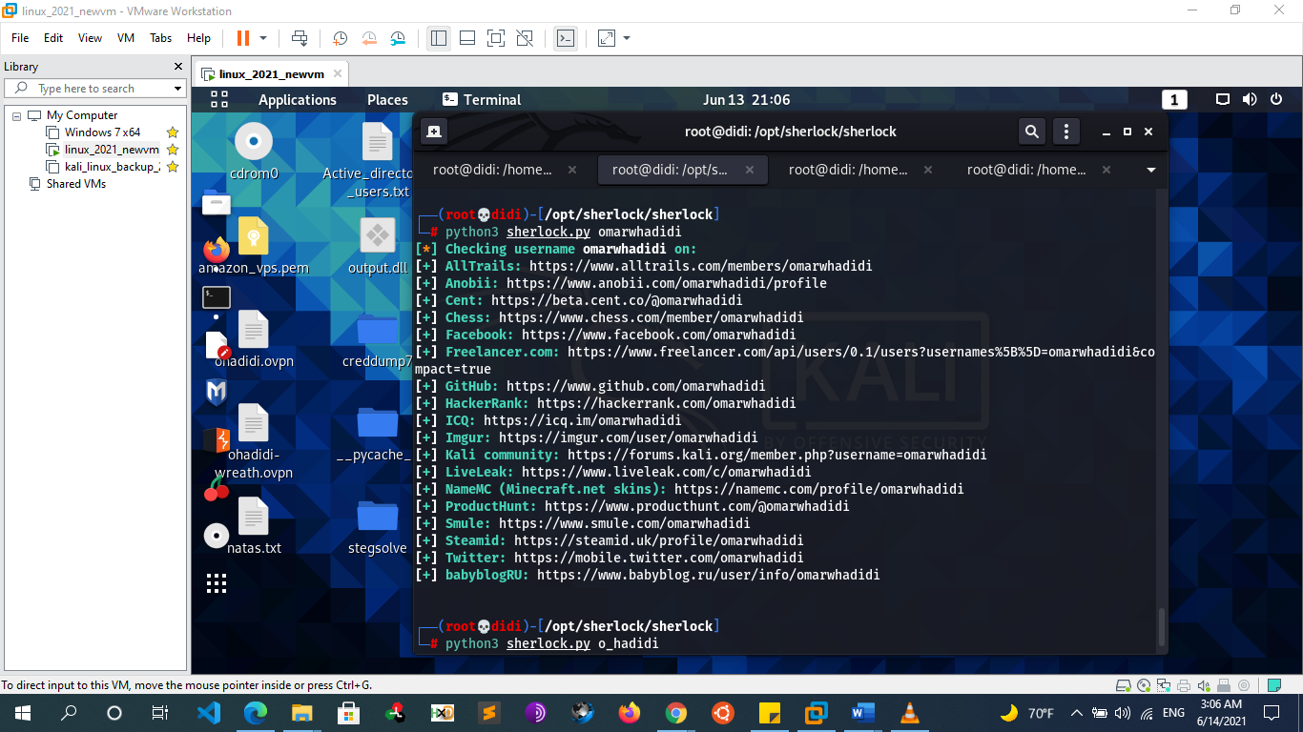

* + - * + **Namechk.com**
      * **At this point of our information gathering phase, we already know some information seen below:**
        + Age
        + Phone Number
        + Business
        + Further searching will tell us:

Email addresses

Addresses

Occupation

Interests

Website Owned

Financial Info

Related documents

* + - **Job search websites**
      * Now we can start looking for job postings and frequenting job boards. Many organizations have a web site section including open positions and career opportunities.
      * This might not seem like harmful information however, an investigator can deduce internal hierarchies, vacancies, projects, responsibilities, weak departments, financed projects, technology implementations and more. If you do not find useful information on the organization website, you can use more specific search engines such as
        + Linkedin
        + Indeed
        + Monster
        + Dice
        + Glacedoor
        + Careerbuilder
        + simplyhired
    - **People Search** 
      * Pipl.com
      * Peoplefinders.com
      * Anywho.com
      * Truecaller.com
      * Peekyou.com
      * Zoominfo.com
      * Peoplelookup.com
      * 123people.com
      * Wink.com
      * Peoplesmart.com
      * Whitepages.com
    - **Email Info Gathering** 
      * **TheHarvester** 
        + Tool that gathers emails, names, subdomains, IPs, and URLs from multiple public data sources.
        + theHarvester -d [website] -l 500 -b {all, baidu, bing, google, linkedin, twitter, virustotal, netcraft, yahoo}
        + theHarvester -d www.psa.com -l 500 -b all

-d to specify the target domain and -b to set the data source to search

* + - * **Metasploit**
        + Use auxiliary/gather/search\_email\_collector
      * **SimplyEmail**
        + git clone https://github.com/killswitch-GUI/SimplyEmail.git
        + ./SimplyEmail.py -all -e TARGET-DOMAIN
    - **Show the email’s password that have been leaked**
      * Haveibeenpwned.com
      * Hacked-emails.com
        + This step can be useful after enumerating emails, we can test if they were pwned or hacked before in any breach and if yes we can go and search for their passwords in that leakage
  + **Metadata info Gathering**
    - **FOCA**
      * As you can imagine, doing this manually can be very tedious and time consuming. A very useful tool that allows us to automatically find and download files is FOCA. By querying search engines like google and bing, Foca is able retrieve files and then attempt to extract metadata such as names, usernames, password, OS etc.
      * Note that this tool works only on Windows unfortunately.
    - **Metagoofil** 
      * **->** download files and metadata about the website
      * metagoofil -d [domain] -t {doc,pdf,xls,ppt,odp,ods,docx,xslx,pptx} -l 200 -n 5 -o [out] -f results.html
    - **exiftool ->** show metada on files
      * apt install exiftool
      * exiftool [file]
  + **Recon Through Open-Source Code**
    - In the following sections, we will discuss various online tools and resources that can be used to passively search for information. One such source of interesting information are open-source projects and online code repositories, such as GitHub GitLab and SourceForge. Code stored online can provide a glimpse into the programming languages and frameworks used by an organization. In some rare occasions, developers have even accidentally committed sensitive data and credentials to public repos.
    - **Github**
      * **Github Dorks**
        + "Company" password
        + "Company" secret
        + "Company" credentials
        + "Company" token
        + "Company" config
        + "Company" key
        + "Company" pass
        + "Company" login
        + "Company" pwd
        + "Company" ssh\_auth\_password
        + "Company" ssh\_user
        + "Company" ssh\_pasword
        + "Company" ftp
        + "Company" security\_credentials
        + "Company" connectionstring
        + "Company" JDBC
        + "Company" send\_key,send\_keys
        + <https://github.com/techgaun/github-dorks/blob/master/github-dorks.txt>
      * **Tools**
        + For larger repos, we can use several tools to help automate some of the searching, such as Gitrob and Gitleaks. Recon-ng also has several modules for searching GitHub. Most of these tools require an access token to use the source code hosting provider’s API.
        + Gitrob
        + gitleaks
    - **Security Header Scanner**
      * There are several other specialty websites that we can use to gather information about a website or domain’s security posture. Some of these sites blur the line between passive and active information gathering, but the key point for our purposes is that a third-party is initiating any scans or checks. One such site, Security Headers, 167 will analyze HTTP response headers and provide basic analysis of the target site’s security posture. We can use this to get an idea of an organization’s coding and security practices based on the results.
      * Securityheaders.com
    - **Pastebin.com** 
      * Pastebin is a website for storing and sharing text. The site doesn’t require an account for basic usage. Many people use Pastebin because it is ubiquitous and simple to use. But since Pastebin is a public service, we can use it to search for sensitive information.
      * site for sharing texts can be useful in recon phase
    - **Stackoverflow.com**
      * is a website for developers to ask and answer coding related questions. The site’s value from an information gathering perspective is in looking at the types of questions a given user is asking or answering. If we can reasonably determine a user on Stack Overflow is also an employee of our target organization, we may be able to infer some things about the organization based on the employee’s questions and answers.
      * For example, if we found a user that is always asking and answering questions about Python, it would be reasonable to assume they use that programming language on a daily basis, and it would likely be used at the organization where they are employed.
      * Even worse, if we find employees discussing sensitive information such as vulnerability remediation on these types of forums, we could discover unpatched vulnerabilities during this phase.
    - **SSL Server Test**
      * Another scanning tool we can use is the SSL Server Test from Qualys SSL Labs.171 This tool analyzes a server’s SSL/TLS configuration and compares it against current best practices. It will also identify some SSL/TLS related vulnerabilities, such as Poodle or Heartbleed
      * https://www.ssllabs.com/ssltest/
  + **IOT (devices) search websites** 
    - **Shodan.io**
      * **Overview**
        + As we gather information on our target, it is important to remember that traditional websites are just one part of the Internet. Shodan is a search engine that **crawls devices connected to the Internet including but not limited to the World Wide Web**. This includes the servers that run websites but also devices like routers and IoT devices.
        + **Google and other search engines look for web server content, while Shodan searches for Internet-connected devices**, interacts with them, and displays information about them. And banners. and indexes the services run on each IP address
        + Shodan searches includes the following protocols

RDP

FTP

Telnet

HTTP(S)

SSH

SNMP

MySQL / MondoDB

and few more

So we can use it to search for devices with default username and password, viewing the configuration of a device, detect server versions, and much more.

* + - * **Example**
        + Let’s say we are performing a pentest on a company, and we want to find out what services one of their servers run. We need to grab their IP address. first

We can do this using ping

We can ping tryhackme.com and the ping response will tell us their IP address.

* + - * + Then once we do this, we put the IP address into Shodan to get:
        + 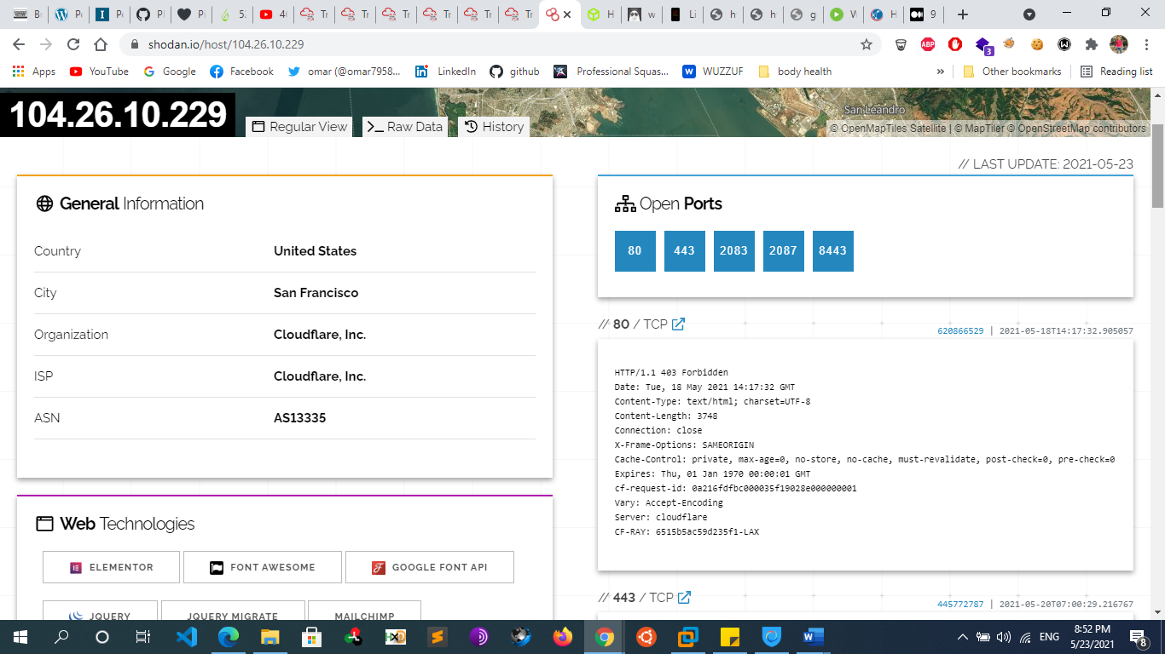
        + We can see that TryHackMe runs on Cloudflare in the United States and they have many ports open. Cloudflare acts as a proxy between TryHackMe and their real servers. If we were pentesting a large company, this isn’t helpful. We need some way to get their IP addresses.
        + We can do this using **Autonomous System Numbers**.

An autonomous system number (ASN) is a global identifier of a range of IP addresses. If you are an enormous company like Google, you will likely have your own ASN for all of the IP addresses you own.

We can put the IP address into an ASN lookup tool such as <https://www.ultratools.com/tools/asnInfo> ,

Which tells us they have the ASN AS14061.

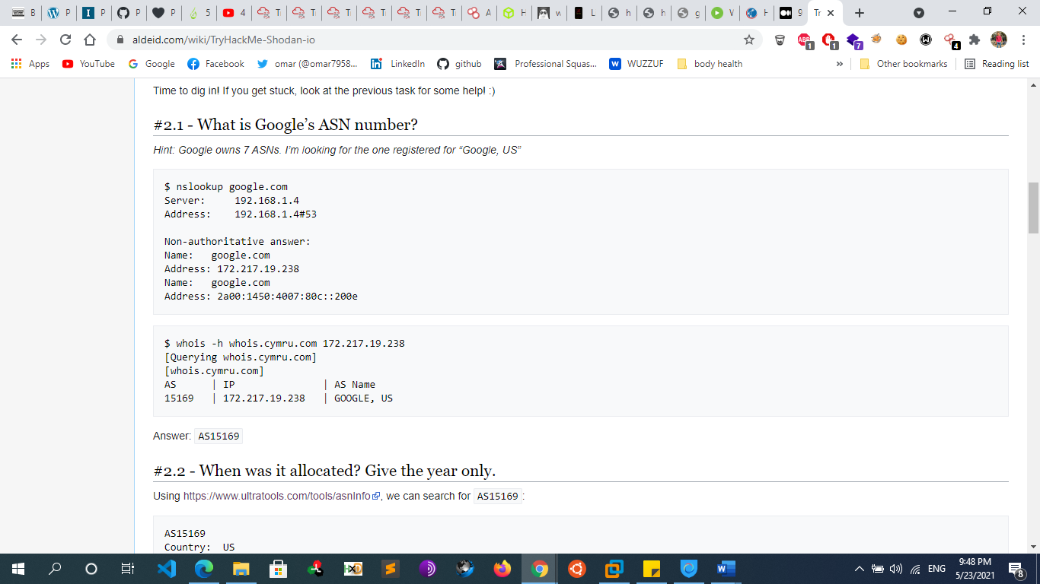

* + - * + 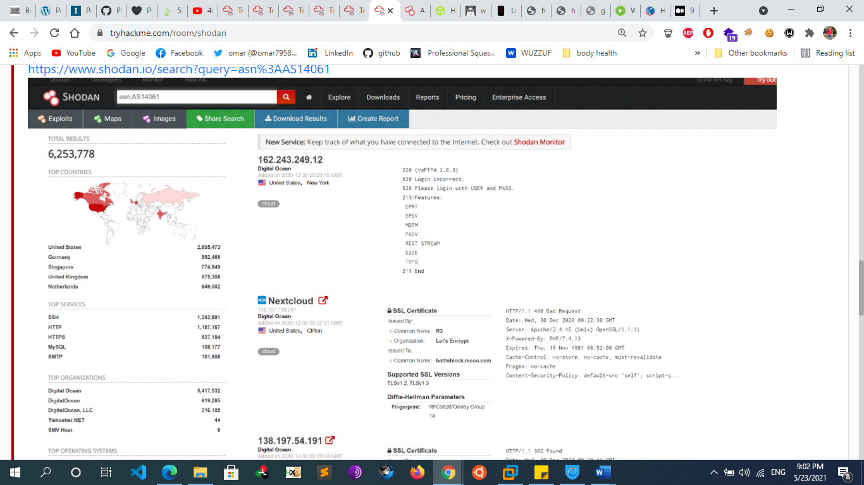
        + On Shodan.io, we can search using the ASN filter. The filter is **ASN:[number]** where number is the number we got from earlier, which is AS14061. Doing this, we can see a whole range 6.2 million websites, in fact) that are on this one single ASN!
        + Knowing the ASN is helpful, because we can search Shodan for things such as coffee makers or vulnerable computers within our ASN, which we know (if we are a large company) is on our network.
      * **Shodan Filters**
        + Here are some nice filters we can use on Shodan:

City

Country

Geo (coordinates)

Hostname: filters results for hosts that contain the value in their hostname

net (based on IP / CIDR)

os (find operating systems)

port

Vuln:[vuln\_name]

let’s us search for IP addresses vulnerable to an exploit. Let’s say we want to find IP addresses vulnerable to Eternal Blue: **Vuln: ms17-010**

CVE search is only allowed to academic or business subscribers

product: [name]

product:MySQL

ASN:[number]

Search ip address for that ASN

[before/after] day/month/year: search only for data that was collected before or after the given date

Server: SQ-WEBCAM

Find webcams

* + - * + Let now see some search examples. Suppose we want to find all the devices running apache and that are in Italy (IT) our search query is :

apache country:IT

* + - * + Shodan has some lovely webpages with Dorks that allow us to find things. Their search example webpages feature some.

**has\_screenshot:true encrypted attention**

Which uses optical character recognition and remote desktop to find machines compromised by ransomware on the internet.

**vuln:CVE-2014-0160**

Internet connected machines vulenrable to heartbleed.

**http.favicon.hash:-1776962843**

Solar Winds Supply Chain Attack by using Favicons:

You can find more Shodan Dorks on GitHub.

* + - * **Shodan API**
        + Shodan.io has an API! It requires an account
        + The API lets us programmatically search Shodan and receive a list of IP addresses in return. If we are a company, we can write a script to check over our IP addresses to see if any of them are vulnerable
      * **Shodan Extension** 
        + Shodan also has an extension.

<https://chrome.google.com/webstore/detail/shodan/jjalcfnidlmpjhdfepjhjbhnhkbgleap>

* + - * + When installed, you can click on it and it’ll tell you the IP address of the webserver running, what ports are open, where it’s based and if it has any security issues.
        + I imagine this is a good extension for any people interested in bug bounties, being quickly able to tell if a system looks vulnerable or not based on the Shodan output.
      * **Shodan Monitor**
        + Shodan Monitor is an application for monitoring your devices in your own network. In their words:
        + Keep track of the devices that you have exposed to the Internet. Setup notifications, launch scans and gain complete visibility into what you have connected.Previously we had to do this using their API, but now we have this fancy application.Access the dashboard via this link:

<https://monitor.shodan.io/dashboard>

* + - **Censys.com**
  + **Recon-ng Framework**
    - recon-ng is a module-based framework for web-based information gathering. Recon-ng displays the results of a module to the terminal but it also stores them in a database. Much of the power of recon-ng lies in feeding the results of one module into another, allowing us to quickly expand the scope of our information gathering.
    - **commands**
      * recon-ng
        + start the framework
        + According to the output, we have no modules installed to use recon-ng. We can add modules from the recon-ng “Marketplace”.
      * help
      * marketplace search [module name]
        + We’ll search the marketplace from the main prompt with marketplace search, providing a search string as an argument.
        + Notice that some of the modules are marked with an asterisk in the “K” column. These modules require credentials or API keys
      * marketplace info [module name]
        + We can learn more about a module by using marketplace info followed by the module name.
      * marketplace install all
        + ->install all the modules on my pc
      * marketplace install [module name]
      * After installing the module, we can load it with module load followed by its name. Then, we’ll use info to display details about the module and required parameters
        + modules search

- > list all modules

* + - * + modules load [module name]

-> same as use module

Ex  : modules load recon/profiles-profiles/profiler

* + - * + info

 -> list module info and options

* + - * + options set [option] [value]

If we use the “default” value, recon-ng will look up the information in its database

* + - * + run

run the module

* + - * + back

return to the main recon-ng prompt and try the

command again

* + - * + show [double tab]

->to show all we can show

* + - * + Show hosts

view stored data

* + - * + show profiles

-> show all profiles resulted from scan

* + **Information Gathering Frameworks**
    - **OSINT Framework**
      * the OSINT Framework includes information gathering tools and websites in one central location. Some tools listed in the framework cover more disciplines than information security. The OSINT framework is not meant to be a checklist, but reviewing the categories and available tools may spur ideas for additional information gathering opportunities
      * <https://osintframework.com/>
      * 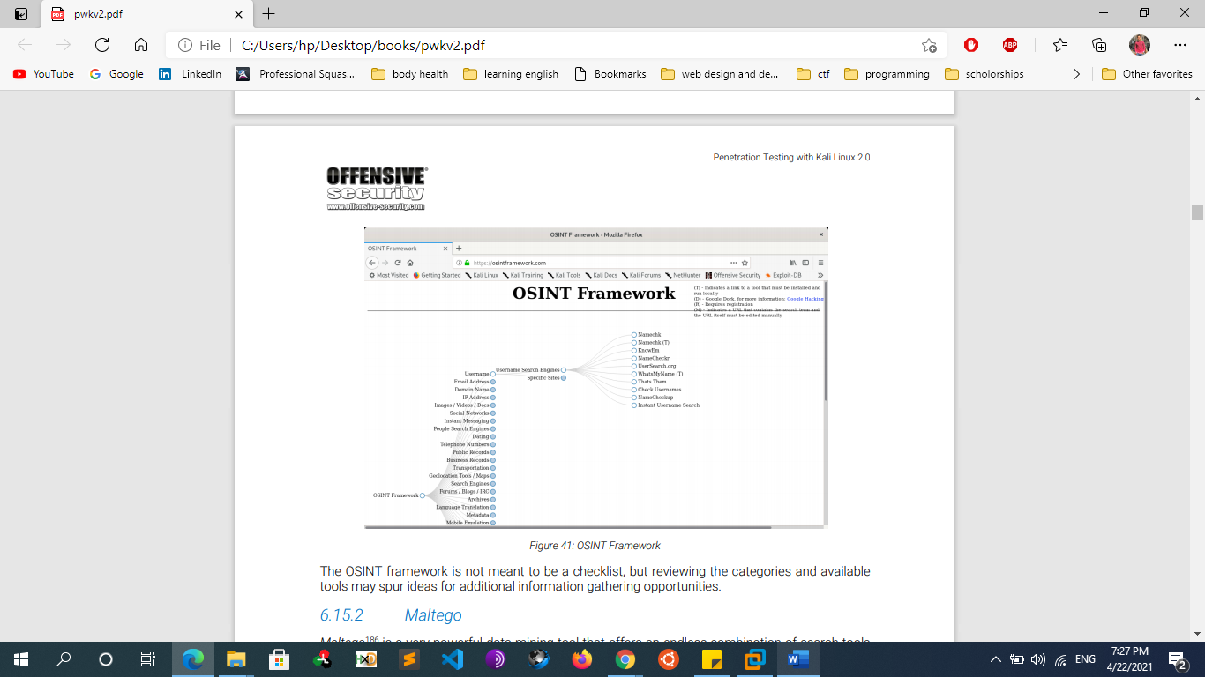
    - **Maltego** 
      * Maltego is a very powerful Gui data mining tool that offers an endless combination of search tools and strategies.
      * Maltego searches thousands of online data sources, and uses extremely clever “transforms” to convert one piece of information into another
      * gather domain owner info , Emails  , domains , ...
  + **Extra Notes**
    - **Image Geolocation [IMINT/GEOINT]**
      * **Overview**
        + **IMINT/GEOINT**, which is short for Image intelligence and geospatial intelligence.
      * **Step 1: [your eye]**
        + **Let's introduce you to your first tool - your eyes!**  
          Before we can apply a tool or a methodology for finding the location of an image, **we should use our eyes to scan the image for important information**. Extracting key data points from the image will allow you to apply the right tool, craft a good Google search or identify which part of the world the image might have been taken in.
        + There are 5 elements of IMINT that you should consider when looking at an image, according to Geoint expert [Benjamin Strick](https://twitter.com/BenDoBrown):

- Context  
- Foreground  
- Background  
- Map markings  
- Trial and error

* + - * + A geolocation challenge like this lacks one important factor, which is the context or the source of the image. In real-world cases, you usually have a context in which the image was produced or shared, usually called context clues. Most of these challenges will not have context clues but you may find clues in the titles and descriptions, or if you're stuck you can use the hint function.
        + **Here are some questions you should ask yourself while analysing:**

Are there any obvious data in the image that reveals the location, like a street name or storefront signs?

Can you determine the country or region of the image by, for instance, which side of the road they drive on, language or architectural characteristics that may reveal a country or continent/region?

Do you recognize road sign styles, nature and environmental characteristics, or popular motor vehicle brands or vehicle types?

What is the quality of any visible infrastructure like? Is the road paved or do you see gravel roads?

Do you see any unique landmarks, buildings, bridges, statues or mountains that can help you geolocate the image?

One of the more obvious ways we can geolocate an image is to look at the image details. Does it contain EXIF data?

* + - * **Step 2: google**
        + your first tool, Google! If you see anything in the image that can be extracted into a keyword, phrase, a company name, telephone number or any other question you may have as a result of scanning the image up and down: GOOGLE IT!
      * **Step 3: image reverse search programs**
        + One of the methods for geolocating an image is to do an image reverse search. This means that we are searching for the image itself online, and if the image has been indexed by search engines, we may find the exact image or we can do a visual search or crop search to help us find similar images.
        + I recommend adding this extension to ease the workflow for when you find images online that you want to do an image reverse on:

**Addon description:** "Perform a search by image. Choose between the image search engines **Google, Bing, Yandex, TinEye and Baidu**."

**Chrome:** [RevEye Reverse Image Search](https://chrome.google.com/webstore/search/RevEye%20Reverse%20Image%20Search?hl=no" \t "_blank)-

**Firefox:**[RevEye Reverse Image Search](https://addons.mozilla.org/nb-NO/firefox/addon/reveye-ris/" \t "_blank)

* + - * + **Yandex reverse image**

Use Yandex first, and then a hundred more times. Then after Yandex, use Bing. Then Google

Yandex will usually provide the best results. However, there is never a guarantee for this, so you should always try multiple search engines if one comes up empty handed

Another neat feature of the Yandex RIS, is that images with text in them are automatically OCRed, meaning that the text is extracted and turned into something machine readable. Of course, this all depends on the image quality and most importantly the text alignment in the image. If it’s written in a straight line, chances are high Yandex can OCR it. Crooked or handwritten text might not work.

* + - * + **Bing reverse image**

Within an image search, Bing allows you to crop a photograph (button below the source image) to focus on a specific element in said photograph, as seen below. The results with the cropped image will exclude the extraneous elements, focusing on the user-defined box.

* + - * + **Google reverse image**

Google will automatically associate a keyword with the picture. Changing this keyword manually will alter the results. In some cases, you might want to try different keywords to get better overall results

* + - * + Remember that changing the crop and the keywords for searching an image may yield completely different results.

**Cropping pictures Improve search results**

* + - * **Step 4: Google maps**
        + When geolocating an image, we want to point out big landmarks we can easily find on a map. Road layouts, business names,
      * **Notes**
        + Geolocating videos aren't much different from geolocating images. A video is just a string of images, usually played at 24 frames(or images) per second. In other words, a video will hold a whole lot more images that can be analyzed, reversed and scrutinized by you.

FFmpeg, which will help you extract the key images from the video

* + - * + It's important to know what is and isn't likely to be in a country. For example, it is unlikely for a regular Catholic church to appear in places where Budhism / islam is the most popular religion.
        + The language used on the shops and vehicles matter too. We can use Google translate to predict what language it could be.
        + Which side of the road the cars are on, the license plates (you normally can find out what country or state the license plate is from), the markings on the road (different countries have different markings), the style of traffic lights, the clothing choices of those walking around.
        + To be good at geolocation, we've got to open our eyes to all that could be. In your country, for example, it may be common to wear coats during the winter periods. However, in other countries it may not be (think Australia).
        + Even the smallest of things that we wouldn't normally think twice about can reveal to us the possible location.
        + One of the more obvious ways we can geolocate an image is to look at the image details. Does it contain EXIF data?
        + What about where it was posted - is there a location tagged on social media?
      * **Resources**
        + https://www.bellingcat.com/resources/how-tos/2019/12/26/guide-to-using-reverse-image-search-for-investigations/
    - **To Host a website there are 2 important steps:**
      * Rent a Domain From any website like Godaddy ,domain.com , namecheap
      * Rent a server/vps or shared hosting to put the website file on it
    - **Target location info gathering**
      * Maps.google.com
      * Google.com/earth
    - **Download websites (mirror)**
      * HTTRACK
      * Wget [website]
      * Surfoffline.com
      * Calluna-software.com
    - **Taking Notes**
      * An information gathering campaign can generate a lot of data, and it’s important that we manage that data well so that we can leverage it in further searches or use it in a later phase. There is no right or wrong way to take notes. However, we may find it easier to retrieve information later on if we keep detailed and well formatted notes.
      * Take Notes for everything you gather you can use MindMaps
    - **Crunchbase/inc**
      * CrunchBase is a database where you can find information about organizations:
        + Companies
        + People
        + Investors and financial information
        + Companies Acquisitions
      * The power of CrunchBase is grounded on the concept of anyone being able to edit information in it.
      * Another useful online resource is [www.inc.com](http://www.inc.com). Inc. focuses its attention on growing companies and provides advice, resources and information to companies. Moreover, Inc. offers a list of the 500/5000 fastest-growing private companies, showing very useful information and statistics on them
    - **Search in Trello site**
      * Ex: site:Trello intext:domain intext:password
* **SCANNING (Active Reconnaissance)** 
  + **Topics**
    - **Network Tracing**
    - **Network Discover**
    - **Port scanning**
    - **Service/Version Scanning**
    - **OS Fingerprinting**
    - **Vulnerability Scanning**
    - **DNS Scanning & Enumeration**
    - **Web application Enumeration**
  + **Network Tracing**
    - determine the network topology and draw a map
  + **Network Discover**
    - **Overview**
      * (ping sweep) identify live hosts on a network
      * To deal with large volumes of hosts, or to otherwise try to conserve network traffic, we can attempt to probe targets using Network Sweeping techniques, in which we begin with broad scans, and use more specific scans against hosts of interest.
    - **Manually with ping**
      * Ping [ip address]
    - **Netdiscover**
      * Netdiscover –I eth0 –r 192.168.1.0/24
    - **Nmap**
      * Nmap –sn –n 192.168.1.0/24
    - **Ping , traceroute , tracert**
  + **Port scanning**
    - **Overview**
      * Port scanning is the process of inspecting TCP or UDP ports on a remote machine with the intention of detecting what services are running on the target and what potential attack vectors may exist
    - **Port scanner tools**
      * **Netcat**
        + Necat main purpose is not a port scanning tool but can be used for learning purpose
        + nc -nvv -w 1 -z 10.11.1.220 3388-3390

The -w option specifies the connection timeout in seconds and -z is used to specify zero-I/O mode, which will send no data and is used for scanning:

-u : udp scan

* + - * **Hping , fping**
      * **Nmap / zenmap**
        + Nmap most modules require root privilege
      * **Unicorn scan**
        + unicornscan -H -msf -Iv 192.168.56.101 -p 1-65535
        + unicornscan -H -mU -Iv 192.168.56.101 -p 1-65535
        + Arguments :

-H resolve hostnames during the reporting phase

-m scan mode (sf - tcp, U - udp)

-Iv - verbose

* + - * **Masscan**
      * **Solarwinds port Scanner**
    - **Port Scanning Techniques** 
      * **Full Tcp Scan (connect scan)** 
        + Default technique if not root user
        + perform the three-way handshake
        + 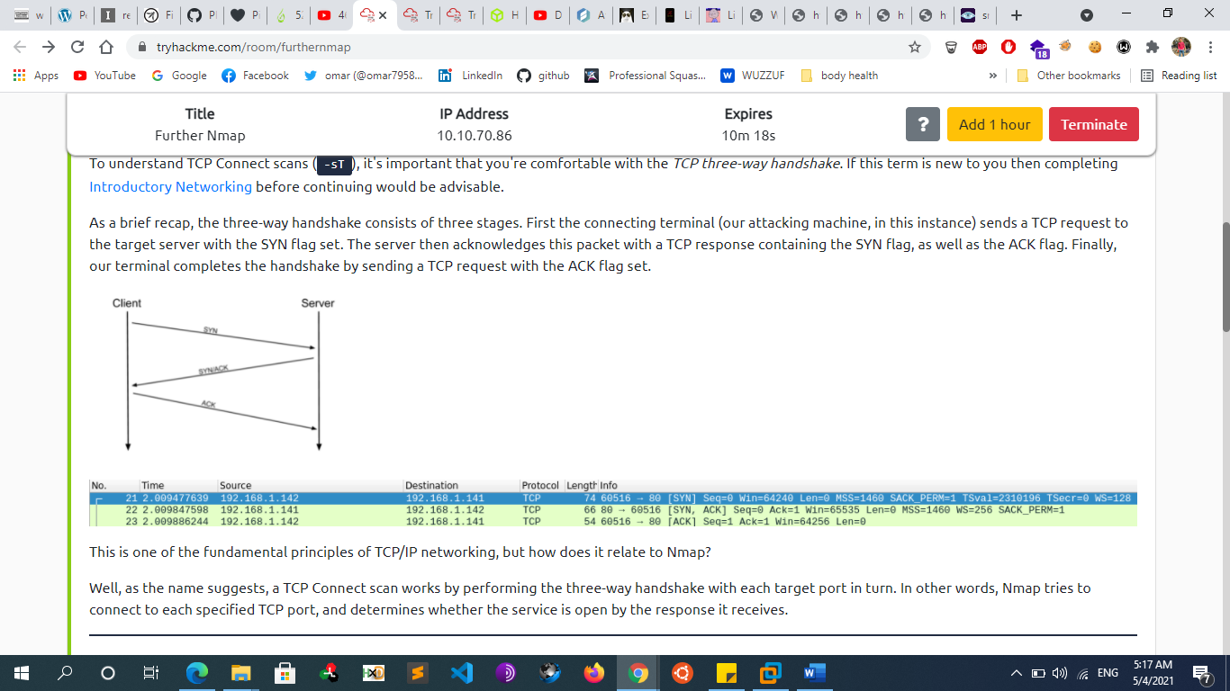
        + In other words, if Nmap sends a TCP request with the SYN flag set to a **closed** port, the target server will respond with a TCP packet with the RST (Reset) flag set. By this response, Nmap can establish that the port is closed.
      * **Stealth Scan** 
        + Doesn’t complete the three-way handshake
        + Please note that term “stealth” refers to the fact that, in the past, primitive firewalls would fail to log incomplete TCP connections. This is no longer the case with modern firewalls and even if the stealth moniker has stuck around, it could be misleading.
        + **Syn scan (half open scan)**

Default technique if root user

SYN scanning is a TCP port scanning method that involves sending SYN packets to various ports on a target machine without completing a TCP handshake. If a TCP port is open, a SYN-ACK should be sent back from the target machine, informing us that the port is open. At this point, the port scanner does not bother to send the final ACK to complete the three-way handshake

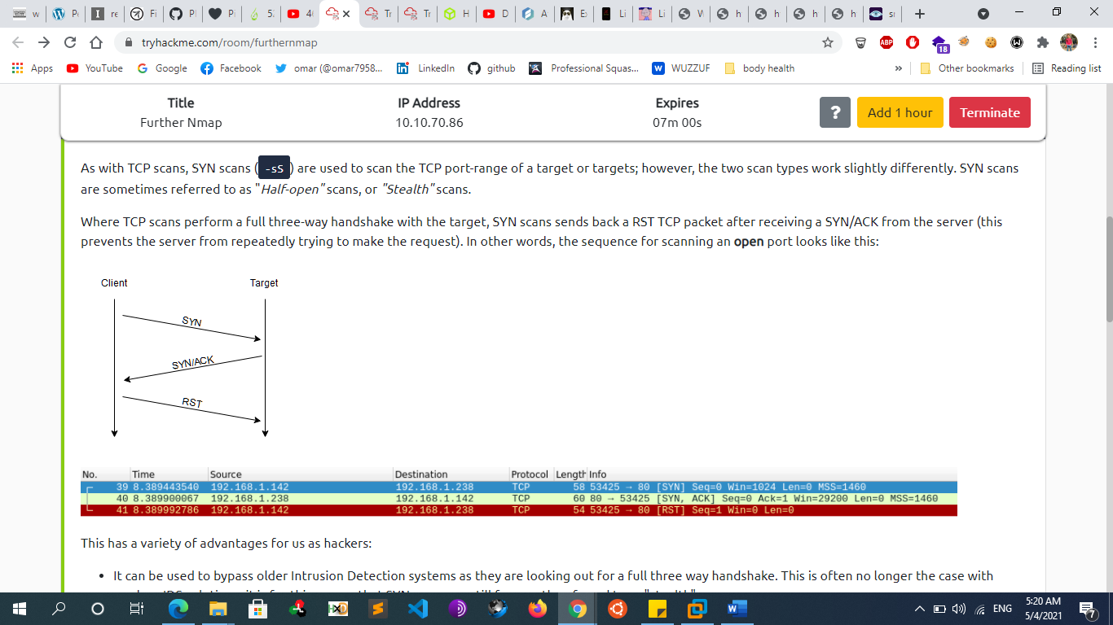



This has a variety of advantages for us as hackers:

It can be used to bypass older Intrusion Detection systems as they are looking out for a full three-way handshake. This is often no longer the case with modern IDS solutions; it is for this reason that SYN scans are still frequently referred to as "stealth" scans.

SYN scans are often not logged by applications listening on open ports, as standard practice is to log a connection once it's been fully established. Again, this plays into the idea of SYN scans being stealthy.

Without having to bother about completing (and disconnecting from) a three-way handshake for every port, SYN scans are significantly faster than a standard TCP Connect scan.

* + - * + **Null Scan**

As the name suggests, NULL scans (-sN) are when the TCP request is sent with no flags set at all. As per the RFC, the target host should respond with a RST if the port is closed

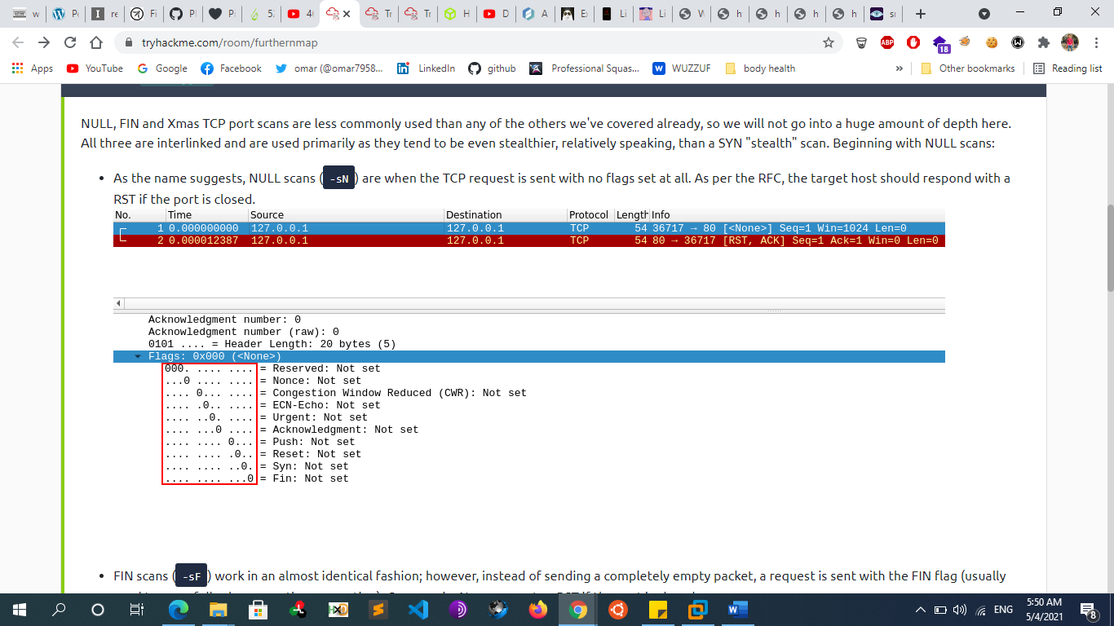



* + - * + **Fin Scan**

FIN scans (-sF) work in an almost identical fashion; however, instead of sending a completely empty packet, a request is sent with the FIN flag (usually used to gracefully close an active connection). Once again, Nmap expects a RST if the port is closed.

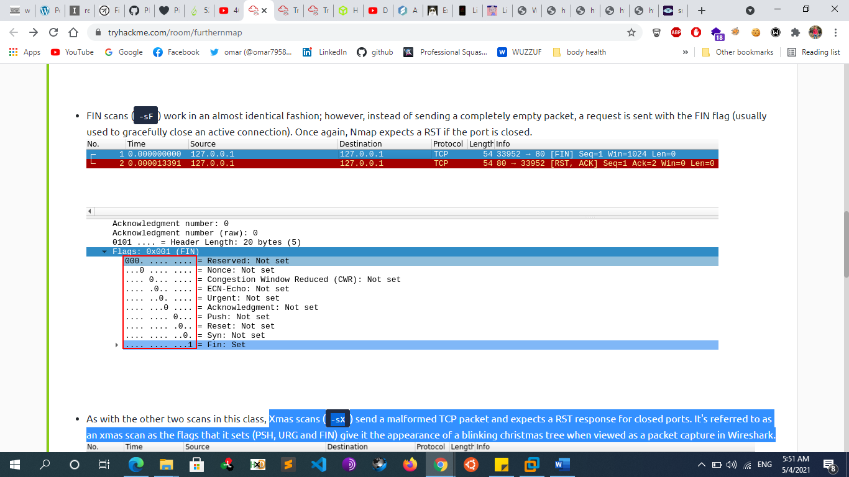



* + - * + **Xmas scan**

Xmas scans (-sX) send a malformed TCP packet and expects a RST response for closed ports. It's referred to as an xmas scan as the flags that it sets (PSH, URG and FIN) give it the appearance of a blinking Christmas tree when viewed as a packet capture in Wireshark.

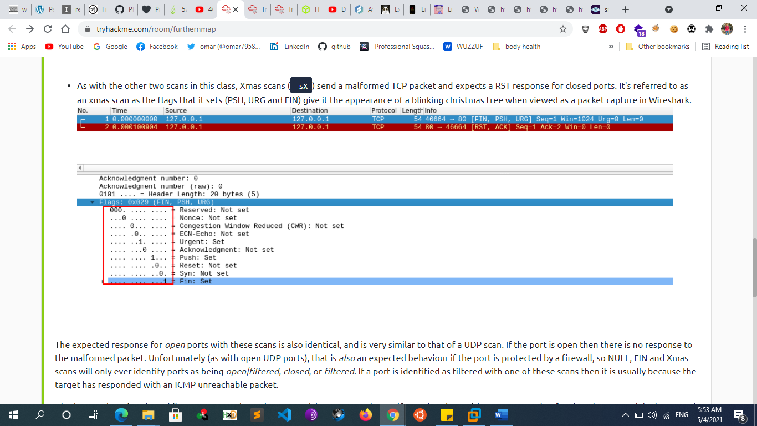



* + - * **Ack Scan**
      * **Mainmon Scan**
      * **Idle Scan**
      * **Udp Scan**
        + When a packet is sent to an open UDP port, there should be no response. When this happens, Nmap refers to the port as being open|filtered. In other words, it suspects that the port is open, but it could be firewalled. If it gets a UDP response (which is very unusual), then the port is marked as open. More commonly there is no response, in which case the request is sent a second time as a double-check. If there is still no response then the port is marked open|filtered and Nmap moves on.
        + When performing a UDP scan, Nmap will use a combination of two different methods to determine if a port is open or closed. For most ports, it will use the standard “ICMP port unreachable” method described earlier by sending an empty packet to a given port. However, for common ports, such as port 161, which is used by SNMP, it will send a protocol-specific SNMP packet in an attempt to get a response from an application bound to that port.
  + **Service/Version Scanning**
    - We can also identify services running on specific ports by inspecting service banners and determine the version of services and protocols
    - Nmap –sV [ip address]
  + **OS Fingerprinting**
    - attempts to guess the target’s operating system and This is possible because operating systems often have slightly different implementations of the TCP/IP stack (such as varying default TTL values and TCP window sizes) and these slight variances create a fingerprint that tools can often identify.
    - Note that OS Fingerprinting is not always 100% accurate, but a best-guess attempt
    - **Passive Fingerprinting:**
      * attempts to guess the target’s operating system without interaction with him (sniffing)
        + **Pof**
        + **Satori**
        + **Network minor**
    - **Active Fingerprinting:**
      * attempts to guess the target’s operating system by inspecting returned packets by interacting with him
      * **Banner grabbing**
        + Nc [ip] [port]
        + Ncat [ip] [port]
        + telnet [ip] [port]
      * **nmap** 
        + nmap –O [ip address]
      * **xprobe2** 
        + xprobe2 -v -p tcp:80:open [IP]
  + **Vulnerability Scanning**
    - **Some comparison** 
      * **Manual scanning vs automated scanning**
      * **Internal scanning vs internet scanning**
      * **Authenticated scanning vs unauthenticated scanning**
        + Most scanners can be configured to run authenticated scans, in which the scanner logs in to the target with a set of valid credentials. In most instances, authenticated scans use a privileged user account in order to have the best visibility into the target system. To run an authenticated scan against a Linux target, we simply enable the SSH service on the Linux target and configure the scanner with valid user credentials. Most scanners will use this access to review package versions and validate configurations in an attempt to discover potential vulnerabilities
        + Authenticated scans generate a wealth of additional information and produce more accurate results at the expense of a longer scan time. Although an authenticated scan can be used during a penetration test (using discovered credentials, for example), it is more commonly used during the patch management process.
    - **Network Vulnerability Scanners**
      * **How Vulnerability Scanners Work**
        + Vulnerability scanner implementations vary, but generally follow a standard workflow. Most automated scanners will:

1. Detect if a target is up and running.

2. Conduct a full or partial port scan, depending on the configuration.

3. Identify the operating system using common fingerprinting techniques.

4. Attempt to identify running services with common techniques such as banner grabbing, service behavior identification, or file discovery.

5. Execute a signature-matching process to discover vulnerabilities.

* + - * **Nessus**
        + manually download the 64-bit .deb file for Kali from the Tenable website:

https://www.tenable.com/downloads/nessus

* + - * + Install Nessus

dpkg -i Nessus-6.9.4-debian6\_amd64.deb

or sudo apt install ./Nessus-X.X.X.deb

* + - * + start the service

/etc/init.d/nessusd start

* + - * + Launch nessus

<https://localhost:8834/>

* + - * + Nessus supports a number of scan types, including:

Basic Network Scan: Generic scan with various checks that are suitable to be used against various target types.

Credentialed Patch Audit: **Authenticated scan** that enumerates missing patches.

Web Application Tests: Specialized scan for discovering published vulnerabilities in Web Applications.

Spectre and Meltdown: Targeted scan for the Spectre231 and Meltdown232 vulnerabilities.

* + - * **Openvas**
        + Apt install openvas
        + Openvas-setup
        + http://localhost:9392
      * **Nexpose**
      * **Acunetix**
      * **Netsparker**
      * **NMAP (NSE)**
        + NSE scripts are located in the /usr/share/nmap/scripts directory.
        + Nmap <ip> --script vuln
    - **Web Vulnerability Scanners**
      * **Nikto**
        + Nikto is a highly configurable Open-Source web server scanner that tests for thousands of dangerous files and programs, vulnerable server versions and various server configuration issues. It performs well, but is not designed for stealth as it will send many requests and embed information about itself in the User-Agent header.

Nikto –h [site]

Basic scanning This scan type will retrieve the headers advertised by the webserver or application (I.e. Apache2, Apache Tomcat, Jenkins or JBoss) and will look for any sensitive files or directories (i.e. login.php, /admin/, etc)

Nikto -h [site] --maxtime=30s

-> limit the scan time because it takes a lot of time

nikto -h http://ip\_address -o report.html

save result in html report

* + - * + **Introduction to Plugins**

Plugins further extend the capabilities of Nikto. Using information gathered from our basic scans, we can pick and choose plugins that are appropriate to our target. You can use the **--list-plugins** flag with Nikto to list the plugins

nikto -h 10.10.10.1 -Plugin [plugin\_name]

apacheusers Attempt to enumerate Apache HTTP Authentication Users

cgi Look for CGI scripts that we may be able to exploit

robots Analyse the robots.txt file which dictates what files/folders we are able to navigate to

dir\_traversal Attempt to use a directory traversal attack (i.e. LFI) to look for system files such as /etc/passwd on Linux

* + - * + **Tuning Your Scan for Vulnerability Searching**

Nikto has several categories of vulnerabilities that we can specify our scan to enumerate and test for. The following list is not extensive and only include the ones that you may commonly use

Nikto -tuning [value] [website]

* + - * + 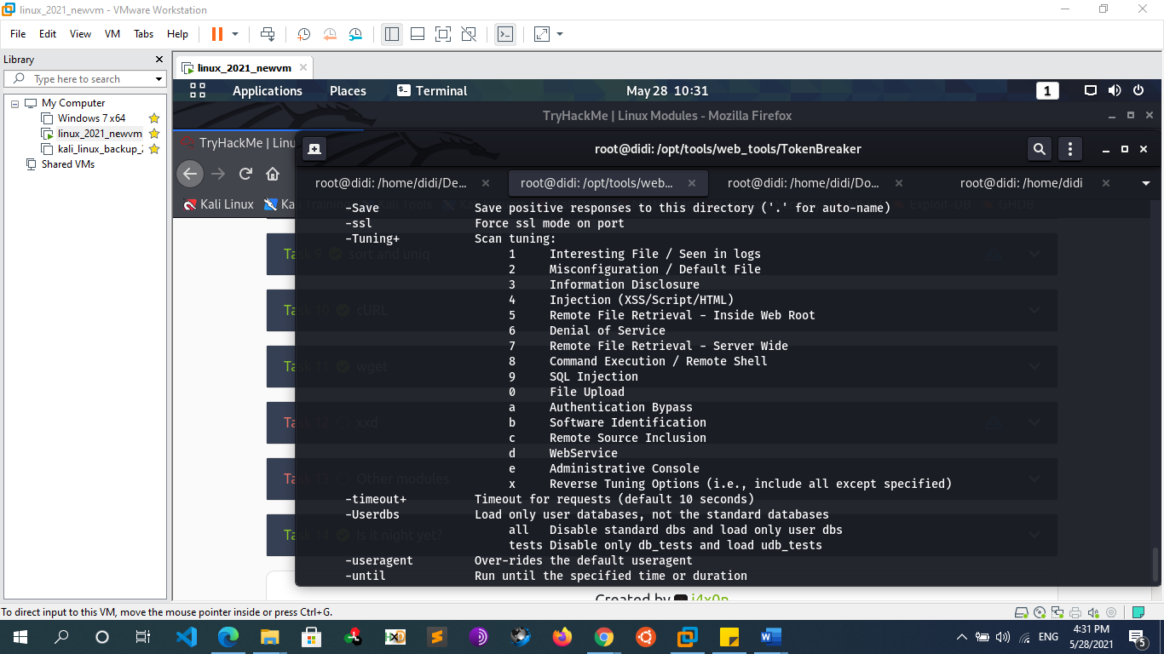
      * **W3af**
      * **Vega**
      * **Wapiti**
      * **Skipfish**
      * **Zed attack proxy (zap)**
      * **sqlmap**
      * **CMS Vulnerability Scanners**
        + **Wpscan**

wpscan --url [website]    -> to get info and possible vulnerabilities of the website

wpscan --url [website]  --enumerate u   -> to get the username of wp-panel

wpscan --url [website] --passwords passwd.txt --usernames [user found]

 -> bruteforce to get the password

* + - * + **joomscan**

joomscan -u [website]

joomscan -u [website]--enumerate-components

* + **DNS Scanning & Enumeration** 
    - **Host**
      * Host [[domain]](http://www.psasquashtv.com)
        + Forward dns lookup
      * Host [ip]
        + Host -t PTR [ip]
        + reverse dns lookup
      * Host –t { ns,mx,soa,A,AAAA,txt,any } [[domain]](http://www.psasquashtv.com)
      * Host –a [[domain]](http://www.psasquashtv.com)
        + -> -a = -V –t any
      * Host –a -v [[domain]](http://www.psasquashtv.com)
        + -> -v = -d = verbose
    - **Nslookup**
      * nslookup [[domain]](http://www.psasquashtv.com)
        + forward lookup
      * nslookup [ip]
        + reverse dns lookup
      * nslookup [[domain]](http://www.psasquashtv.com) [Name server]
        + using specific dns server
      * nslookup –query={any,mx,ns,soa} [[domain]](http://www.psasquashtv.com)
      * nslookup -timeout=10 [[domain]](http://www.psasquashtv.com)
        + change default timeout to wait for reply
      * nslookup –debug [[domain]](http://www.psasquashtv.com)
    - **Dns Automation Tools**
      * **Dig**
        + **Dns Query**

dig google.com {A|AAAA|NS|MX|CNAME|ANY} +noall +answer

dig @8.8.8.8 sci.alexu.edu.eg A +norecurse

* + - * + **Zone Transfer**

dig [domain] NS

Dig @[nameserver] [domain] axfr ->try with all name server founds

* + - * **dnsrecon**
        + Dnsrecon –d [domain]
        + Dnsrecon –d [domain] -a
        + dnsrecon -d microsoft.com -t axfr
        + dnsrecon -d [domain] -t axfr
      * **Dnsenum**
        + Dnsenum -d [domain]
        + Dnsenum –enum [domain]
      * **Dnswalk**
        + Dnswalk [doamain.] -> dot in the end of the domain
        + dnswalk -adilrfFm [domain.]
      * **Fierce**
        + Fierce –dns [domain]
        + Fierce –dns [domain] –threads 10

->default threads = 1

* + - * **Dnstracer**
        + Dnstracer [domain]
      * **Dnsmap**
        + Dnsmap [domain]
      * **Nmap**
        + nmap --script=broadcast-dns-service-discovery 192.168.1.3

The script first sends a query for \_services.\_dns-sd.\_udp.local to get a list of services. It then sends a follow-up query for each one to try to get more information.

* + - * + nmap -T4 -p 53 --script dns-brute www.hackingarticles.in
    - **Dns Zone Transfer**
      * A zone transfer is basically a database replication between related DNS servers in which the zone file is copied from a master DNS server to a slave server. The zone file contains a list of all the DNS names configured for that zone. Zone transfers should only be allowed to authorized slave DNS servers but many administrators misconfigure their DNS servers, and in these cases, anyone asking for a copy of the DNS server zone will usually receive one. This is equivalent to handing a hacker the corporate network layout on a silver platter. All the names, addresses, and functionality of the servers can be exposed to prying eyes
      * **Example**
        + Host

Host -t ns [domain]

host -t ns megacorpone.com | cut -d " " -f 4

attempt zone transfer requests against all the DNS servers found in a given domain

Host –l [hostname] [name server]

host -l megacorpone.com ns1.megacorpone.com

host -l megacorpone.com ns2.megacorpone.com

…….

* + **Web application Enumeration**
    - **Steps**
      * Medium Scope Reconnaissance
        + Step 1: Subdomain Enumeration
        + Step 2: Getting Live Subdomains
        + Step 3:

visual Recon (aquatone)

WayBackUrl enum

* + - * + Step 4:

Analyzing web technologies

Website Crawling

Directory Bruteforcing

* + - * + Step 5:

Check JavaScript codes

* + - * Large Scope Reconnaissance
        + Autonomous system number (ASN) Recon
        + Acquisations
      * Others
        + gitHub leaks
        + s3 bukets
        + subdomain takeover
      * Automated Tools
      * Resources
    - **Content Discovery Vs Assets Discovery** 
      * **Assets Discovery**
        + Asset discovery consists of finding all the digital online assets owned by a particular company. For example: Google owns google.com, YouTube.com, nest.com (acquisition), and a ton of other assets that may be a part of their bug bounty program. You can usually find these through searching on Google, Crunchbase, or Wikipedia. Each of these assets have a domain and each domain may have its own subdomains. For example Google.com has mail.google.com, drive.google.com, cloud.google.com, store.google.com and more.
        + Services like crt.sh, censys.io and shodan …etc. allow you to search through their data and look for certificates for a particular organization. If a subdomain doesn’t have a SSL Certificate we may rely on google or on tools that enumerate subdomains via Bruteforcing

IP addresses

domain names/certificate transparency (crt.sh)

subdomains

open ports

* + - * **Content Discovery**
        + Content discovery helps us to find additional/sensitive folders, endpoints (files), documentation, or features that may not be directly accessible on the site. This also includes finding administration panels, files with sensitive debug/diagnosis information, API documentation, or hidden features available to for users with higher privileges. This can be done by crawling the site using Burp Suite or by using other tools.

Files or Folders

Hidden Endpoints or Functionality

* + - **Subdomain Enumeration**
      * **Overview**
        + **What is Subdomain Enumeration?**

Sub-domain enumeration is the process of finding sub-domains for one or more domain(s). It is an essential part of the reconnaissance phase.

* + - * + **Subdomain Enumeration Techniques**

Passive Enumeration (Subdomain Scrapping)

Subdomain Enumeration by Google Dorking

Subdomain Enumeration by Certificate Transparency (CT)

Subdomain Enumeration by Online DNS tools and services (DNS Aggregators)

Subdomain Enumeration by FDNS Dataset

Subdomain Scrapping Using Tools

Amass

Subfinder

Active Enumeration

Subdomain brute forcing

Subdomain Enumeration by HTTP(CSP) Header

Subdomain Enumeration by Zone Transfer

Subdomain Enumeration by Dnssec walking

* + - * **Passive Subdomain Enumeration (Subdomain Scrapping)**
        + **Subdomain Enumeration by Google Dorking**

Search engines like Google and Bing supports various advanced search operators to refine search queries. These operators are often referred to as “Google dorks”.

We can use “site:” operator in Google search to find all the sub-domains that Google has found for a domain. Google also supports additional minus operator to exclude sub-domains that we are not interested in Example

“site:\*.wikimedia.org -www -store -jobs -uk”

Google dorks are useful for finding new subdomains

site:wikipedia.org

site:\*.wikipedia.org -www -store -jobs -uk

Bing also support dorks and can give others results

site:

When you use the Google Dork: site:\*.example.com, NEVER forget to check

Site: \*.\*.example.com

site: \*.\*.\*.example.com

**Also** You can Google the:

Copyright text

Terms of service text

Privacy Policy text

**Example**

"© 2006-2020 Company, Corp." -site:\*.domain.com inurl:company

"© 2019 twitch Interactive, Inc." inurl:twitch

"© 2019 twitch Interactive, Inc." inurl:twitch -www.domain.com

* + - * + **Subdomain Enumeration by Certificate Transparency (CT)**

is a project under which a Certificate Authority(CA) has to publish every SSL/TLS certificate they issue to a public log. An SSL/TLS certificate usually contains domain names, sub-domain names and email addresses. This makes them a treasure trove of information for attackers.

The easiest way to lookup certificates issued for a domain is to use search engines that collect the CT logs and let’s anyone search through them. Few of the popular ones are listed below -

<https://crt.sh/?q=%25taregt.com>

curl -s https://crt.sh/\?q\=**%25.example.com**\&output\=json | jq -r '.[].name\_value' | sed 's/\\*\.//g' | sort -u

https://censys.io/

https://developers.facebook.com/tools/ct/

<https://google.com/transparencyreport/https/ct/>

The downside of using CT for sub-domain enumeration is that the domain names found in the CT logs may not exist anymore and thus they can’t be resolved to an IP address. You can use tools like massdns in conjunction with CT logs to quickly identify resolvable domain names.

# ct.py - extracts domain names from CT Logs(shipped with massdns)

# massdns - will find resolvable domains & adds them to a file

./ct.py icann.org | ./bin/massdns -r resolvers.txt -t A -q -a -o -w icann\_resolvable\_domains.txt –

Resources

https://blog.appsecco.com/certificate-transparency-the-bright-side-and-the-dark-side-8aa47d9a6616

* + - * + **Subdomain Enumeration by Online DNS tools and services**

**Overview**

Also known as subdomain Scraping or DNS Aggregators

There are a lot of the third party services that aggregate massive DNS datasets and look through them to retrieve sub-domains for a given domain.

VirusTotal runs its own passive DNS replication service, built by storing DNS resolutions performed when visiting URLs submitted by users. In order to retrieve the information of a domain you just have to put domain name in the search bar

DNSdumpster is another interesting tools that can find potentially large number of sub-domains for a given domain

**Example**

VirusTotal Passive DNS replication

Netcraft - Search DNS

https://pentest-tools.com/

<https://dnsdumpster.com/>

<http://dnsgoodies.com>

<https://www.shodan.io/>

<https://censys.io>

* + - * + **Subdomain Enumeration by FDNS Dataset**

There are projects that gather Internet wide scan data and make it available to researchers and the security community. The datasets published by these projects are a treasure trove of sub-domain information.

Forward DNS dataset is published as part of Project Sonar. This data is created by extracting domain names from a number of sources and then sending an ANY query for each domain. The data format is a gzip-compressed JSON file. We can parse the dataset to find sub-domains for a given domain. The dataset is massive though (20+GB compressed, 300+GB uncompressed)

Command to parse & extract sub-domains for a given domain

curl -silent https://scans.io/data/rapid7/sonar.fdns\_v2/20170417-fdns.json.gz | pigz -dc | grep “.icann.org” | jq

wget https://opendata.rapid7.com/sonar.fdns\_v2/2019-11-29-1574985929-fdns\_a.json.gz

cat 20170417-fdns.json.gz | pigz -dc | grep ".target.org" | jq

—

SonarSearch is a project built around the Rapid7 Sonar's database

https://github.com/Cgboal/SonarSearch

An API instance is available at <https://omnisint.io/>. Crobat is a CLI tool designed to query this API

crobat -h

Usage of crobat:

-r string

Perform reverse lookup on IP address or CIDR range. Supports files and quoted lists

-s string

Get subdomains for this value. Supports files and quoted lists

-t string

Get tlds for this value. Supports files and quoted lists

-u Ensures results are unique, may cause instability on large queries due to RAM requirements

* + - * + **Subdomain Scrapping Using Tools**

**Overview**

Doing this manually is a headache so the next set of tools scrape domain information from all sorts of projects that expose databases of URLs or domains

**Amass**

Amass enum -d domain.com

./amass enum --passive -d example.com -o result1.txt

**Subfinder**

Installation

apt-get install golang

go get github.com/subfinder/subfinder

git clone https://github.com/subfinder/subfinder

cd subfinder

go build

Usage

./subfinder -d example.com -o result.txt -v

**Assetfinder**

Assetfinder -subs-only domain.com | tee -a all\_sub.txt

**Github-subdomain.py**

This script is good for scraping GitHub for subdomains

Github-subdomain.py -d “domain.com” > domain.txt

* + - * **Active Subdomain Enumeration**
        + **Subdomain Brute forcing**

**Overview**

Brute force means guessing possible combinations of the target until the expected output is discovered. So, in the subdomain context, the brute-forcing is to try the possible combination of words, alphabets, and numbers before the main domain in order to get a subdomain that is resolved to IP address. Sometimes subdomains are not indexed on search engines and are not available on online DNS aggregators sites in that case brute forcing is the best way to find out the subdomains which may have been forgotten by the organization. It is like a treasure for an adversary.

Two techniques for subdomain enumeration using brute force:

Dictionary brute force

In the dictionary brute force, we directly use the wordlist to a brute force domain name to find valid subdomains.

Tools:

Sublister

Knockpy

Fierce

Subfinder

Subbrute

Amass

Dnsrecon

Aquatone

Bluto-Old

DNS-Discovery

Dnssearch

Permutation brute force

In permutation brute force, we create a new resolved subdomain list from already known subdomains/domains by using permutation, mutation, and alteration with a wordlist.

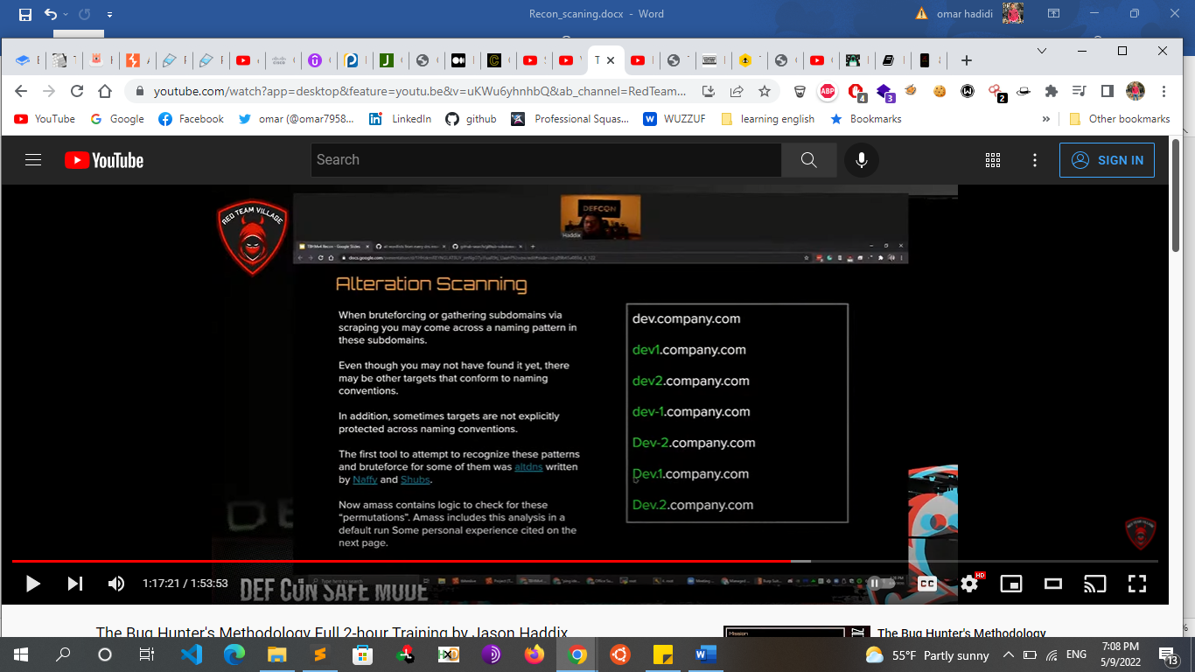

Tool:

altdns

**Dictionary Bruteforce Tools**

**Sublist3r**

Installation

git clone https://github.com/aboul3la/Sublist3r

cd Sublist3r

pip install -r requirements.txt

alias sublist3r='python /path/to/Sublist3r/sublist3r.py -d '

Usage

python sublist3r.py -v -d [website] -o result.txt

**Amass**

Installation

https://github.com/OWASP/Amass/releases

unzip amass\_v3.1.9\_linux\_amd64.zip

cd amass\_v3.1.9\_linux\_amd64

Usage

./amass enum --active -d example.com -o result1.txt

Amass enum -brute -d example.com -src

Amass enum -d example.com -w yourlist.com

**Knokpy**

Git clone <https://github.com/guelfoweb/knock.git>

Python Knockpy.py [website]

Python Knockpy.py [website] -w subdomains.txt

**Subbrute**

python subbrute.py [website]

**massdns**

./subbrute.py /root/work/bin/all.txt $TARGET.com | ./bin/massdns -r resolvers.txt -t A -a -o -w massdns\_output.txt

**AssetFinder**

assetfinder --sub-only [example.com](http://example.com/) > example.txt

Ex: cat example.txt | httprobe | tee active.txt

**Fierce**

Fierce -dns target.com

Fierce -dns target.com -wordlist <name.txt>

**Gobuster**

the "dns" mode. This allows Gobuster to brute-force subdomains.

gobuster -m dns -u google.com -w /usr/share/wordlists/dirb/common.txt

-t [nb]: set threads number

**-fw option** to enable force processing parameter to continue the attack even if there is any Wildcard Domain

gobuster -m dns -u google.com -t 100 -w /usr/share/wordlists/dirb/common.txt -i

show subdomains with their ip

-cn : show their cname

**WFUZZ**

Wfuzz -c -f sub-fighter -w wordlist.txt -u “http:// example.com” -H “HOST:FUZZ.example.com”

**Dnsrecon**

dnsrecon -d microsoft.com -g

-g: perform Google enumeration with standard enumeration

**Theharvester**

theharvester -d microsoft.com -b google -l 200 -f /root/Desktop/msresults.html

We will use google as the search engine, we will limit the results to 200, and also store the results into a HTML file

**Recon-ng**

Netcraft Module

Show workspaces

Workspaces add google.com

Use netcraft

Show options

Set source google.com

Run

Show hosts

Resolve Module (find ip for each subdomain)

Use recon/hosts-hosts/resolve

Show options

Run

Show hosts

Freegeoip (find location of each server)

Use freegeoip

Show options

Run

Show hosts

Report

Use reporting/html

Show options

Set CREATOR omar

Set CUSTOMER Hackerone

Set FILENAME /root

run

**Notes**

Wordlists

Daniel Miessler’s DNS Discovery.

Commonspeak2

https://github.com/assetnote/commonspeak2-wordlists/blob/master/subdomains/subdomains.txt

Jhaddix’s all.txt

The all.txt is a collection of all the different wordlist used by all the different sub-domain bruteforcing tools. You can find it over here Jason Haddix' subdomain compilation

<https://gist.githubusercontent.com/jhaddix/86a06c5dc309d08580a018c66354a056/raw/f58e82c9abfa46a932eb92edbe6b18214141439b/all.txt>

* + - * **Subdomain Enumeration by HTTP Header**
        + Content Security Policy (CSP) is a response header that tells the browser from what sources it is allowed to include and execute resources.
        + It is like a filter where sources are mentioned and in sources, the domains and subdomains are mentioned. An adversary may use this information to enumerate more subdomains and other domains that are allowed by the organization.

<https://github.com/0xbharath/domains-from-csp>

* + - * + Sometimes you will find pages that only return the header Access-Control-Allow-Origin when a valid domain/subdomain is set in the Origin header. In these scenarios, you can abuse this behavior to discover new subdomains.

ffuf -w subdomains-top1million-5000.txt -u http://10.10.10.208 -H 'Origin: http://FUZZ.crossfit.htb' -mr "Access-Control-Allow-Origin" -ignore-body

* + - * **Subdomain Enumeration by Zone Transfer**
        + DNS zone transfer is the process of replication DNS database or DNS records from the primary name server to the secondary name server.

Zone transfer is a type of DNS transaction where a DNS server passes a copy of full or part of it’s zone file to another DNS server

* + - * + The DNS zone transfer functionality used by an adversary only when the primary name server is configured to replicate the zone information to any server. An adversary acts as a slave and asks the master for a copy of the zone records. If zone transfers are not securely configured, anyone can initiate a zone transfer against a nameserver and get a copy of the zone file. By design, zone file contains a lot of information about the zone and the hosts that reside in the zone
        + Only a list of pre-defined hosts should be able to perform this operation. However, it's sometimes possible to retrieve information from internal zones by asking publicly available servers.
        + Types of information gathered by zone transfer

Subdomains

Email address (Could help in phishing)

Current serial number (Change in serial no. may indicate changes in the organization)

Email server (Could help in phishing)

Name server

Location may be disclosed by LOC record

The IP address of the website

Services running in the organization by SRV record

* + - * + Example

dig +multi AXFR @ns1.insecuredns.com insecuredns.com

dig AXFR int @z.hackycorp.com

dig AXFR internal\_zone @z.hackycorp.com

dnsrecon -a -d tesla.com

* + - * **Subdomain Enumeration by Dnssec walking**
        + Due to the way non-existent domains are handled in DNSSEC, it is possible to “walk” the DNSSEC zones and enumerate all the domains in that zone. You can learn more about this technique from here.
        + For DNSSEC zones that use NSEC records, zone walking can be performed using tools like ldns-walk
        + → zone walking

ldns-walk @ns1.insecuredns.com insecuredns.com

ldns-walk insecuredns.com

* + - * + Some DNSSEC zones use NSEC3 records which uses hashed domain names to prevent attackers from gathering the plain text domain names. An attacker can collect all the sub-domain hashes and crack the hashes offline. Tools like nsec3walker, nsec3map help us automate the collecting NSEC3 hashes and cracking the hashes. Once you install nsec3walker, you can use the following commands to enumerate sub-domains of NSEC3 protected zone

# Collect NSEC3 hashes of a domain

./collect icann.org > icann.org.collect

cat icann.org.unhash | grep "icann" | awk '{print $2;}'

# Undo the hashing, expose the sub-domain information.

./unhash < icann.org.collect > icann.org.unhash

# Listing only the sub-domain part from the unhashed data

cat icann.org.unhash | grep "icann" | awk '{print $2;}'

* + - * + Resources

https://niiconsulting.com/checkmate/2020/10/active-subdomain-enumeration-part-2/

* + - * **Notes**
        + collect all these informations from subdinder + amass + crtfinder + sublist3r + google\_dorks etc… and collect all of them into one text file all\_subdomains.txt Now we have 1 text file contains all subdomains: **all\_subdomains.txt**

use altdns to collect subdomains form subdomains, for example sub.sub.sub.domain.com. collect all these info into text file altdns\_subdomain.txt

* + - * + **pass all\_subdomains.txt to 2 directions**

Finding Live Subdomains (httpx/httprobe)

Port Scanning: nmap or masscan to scan all ports and discover open ports + try to brute force these open ports if you see that these ports may be brute forced, use **brute-spray** to brute force these credentials collect all the results into text file nmap\_results.txt (run it on VPS because take lot time)

nmap -sV -iL subdomains.txt -oN scaned-port.txt --script=vuln

Massscan -p1-65535 -iL $ipfile —max-rate 1800 -oG $outPutfile

* + - **Finding Live Subdomains**
      * **Overview** 
        + Pass the text file over httpx or httprobe , these tools will filter all subdomains and return only live subdomains which works on ports 80 and 443
        + take these live subdomains and collect them into separate file live\_subdomains.txt. Now we have 2 text files all\_subdomains.txt + live\_subdomains.txt
      * **Tools**
        + **HTTProbe**

**Example**

cat subdomains | httprobe | tee -a live\_domains

* + - * + **HTTPX**

**Example**

cat subdomains.txt | httpx -o live-subdomains.txt

* + - * **Notes**
        + **pass live\_subdomains.txt to 2 directions**

take the live\_subdomains.txt file and pass it over waybackurls tool to collect all links which related to all live subdomains and collect all these links into new file waybackurls.txt

Also pass it to a visual recon tool to take screenshots

* + - * + **Or you can skip these 2 steps and pass it directly over directory brutefocing**
        + Now we have 3 text files all\_subdomains.txt + live\_subdomains.txt+ waybackurls.txt. take all subdomains text file and pass it over dirsearch or ffuf to discover all hidden directories.

<https://community.ibm.com/database_conf.txt>

* + - * + Also use live\_subdomains.txt and search for credentials in GitHub by using automated tools like GitHound or by manual search (I’ll put pretty reference in the references section). collect all these informations into text file GitHub\_search.txt
    - **visual Recon (Screenshots)**
      * Now that you have discovered all the web servers present in the scope (among the IPs of the company and all the domains and subdomains) you probably don't know where to start. So, let's make it simple and start just taking screenshots of all of them. Just by taking a look at the main page you can find weird endpoints that are more prone to be vulnerable.
      * Get all the domains in one file, make sure all domains are listed only once (uniq command in Linux). Provide the list to a tool which will make a screen shot of every domain:
        + EyeWitness
        + Aquatone
        + webscreenshot.py
      * **Eyewitness**
        + An example of usage:

sudo ./EyeWitness.py -f live\_subdomains.txt --prepend-https --web

sudo ./EyeWitness.py -f live\_subdomains.txt --headless --prepend-https

The --prepend-https options make sure it will take a screen shot of port 80 (HTTP) and 443(HTTPS)

WebScreenshot

wmap : Chrome extension.

* + - * **Aquatone**
        + When you've used aquatone-discover to gather sub-domains, you can use the aquatone-gather to make screenshots of the sub-domains. Make sure you first run aquatone-scan.
        + Requirements For Aquatone

install google chrome

wget https://dl.google.com/linux/direct/google-chrome-stable\_current\_amd64.deb

sudo apt install ./google-chrome-stable\_current\_amd64.deb

* + - * + install aquatone

Method 1

<https://github.com/michenriksen/aquatone/releases/download/v1.7.0/aquatone_linux_amd64_1.7.0.zip>

Method 2

git clone https://github.com/michenriksen/aquatone.git

cd aquatone/

gem install aquatone

* + - * + Usage

sudo mv aquatone /usr/local/bin/

cat live\_subdomains.txt | aquatone

* + - * **webscreenshot**
        + Requirements for WebScreenshot

pip install webscreenshot pip install selenium

* + - * + Usage

python webscreenshot.py -i live\_domains output example

* + - * **Note**
        + 401/403 response

After all the screenshots are made, go through the list and search for the ones which gave you a 401/403 response. Copy and paste these and throw them in a list. Use the waybackmachine and check if you can find some directories. Maybe the organization forgot to put the right permissions on certain directories or files. Tools u can use for this:

WayBackUrls

WayBackUnifier

ReconCat

* + - **Waybackurl Enum**
      * Archive.org is another great resource to find old robots.txt files that may contain old endpoints and other sensitive information, find older versions of the site in order to analyze the source and gather more information, and find other old and forgotten subdomains and dev environments. We can do all of this by just visiting Archive.org, searching for our target, picking an older date (maybe from a year or two ago), and clicking around the website.
      * Archive.org is also a great place to find older javascript files that may have still be available to read from. Using this method, we can find more outdated functionalities and endpoints.
      * After gathering a list of old and new javascript files, we can create a full list of all the endpoints mentioned in those javascript files using **JSParser:**
        + https://github.com/nahamsec/JSParser
      * This could also be automated (and it has been). Using waybackurl.py and waybackrobots.txt, we can find all the information above by running one of the scripts and waiting for the results.
        + WaybackMachine (or WaybackUnifier, a wrapper around Waybackmachine) Given a URL, it queries Waybackmachine for all its versions, tracks the unique parts from each version & creates a unified file that contains these unique parts
        + You can use it on:

robots.txt (trick shared by @zseano)

API documentation pages (trick shared by @filedescriptor)

JS files

Look for old endpoints & leaked API keys (it doesn’t matter if the syntax is messed up)

HTML pages to find comments disclosing sensitive information, more JS code, old endpoints, old input names

* + - * + You can also uses as CLI tool

https://github.com/tomnomnom/waybackurls

cat domains.txt | waybackurls > urls

* + - * + Notes

Cache pages

http://cachedview.com/

<https://www.giftofspeed.com/cache-checker/>

**Pass the waybackurl.txt to 2 directions**

JS parser: use grep to collect all js files form waybackurls.txt as cat waybackurls.txt | grep js > js\_files.txt

Also pass waybackurls.txt file over gf tool and use gf-patterns to filter the links to possible vulnerable links, for example if the link has parameter like ?user\_id= so this link may be vulnerable to SQLI or IDOR, if the link has parameter like ?page= so this link may be vulnerable to lfi. collect all this vulnerable links into directory vulnerable\_links.txt and into this directory have separated text files for all vulnerable links gf\_sqli.txt , gf\_idor.txt ,etc.

Also pass all\_subdomain.txt + waybackurls.txt + vulnerable\_links.txt to nuclei “Automation scanner” to scan all of them

* + - **Analyzing web technologies**
      * **Overview**
      * **Tools** 
        + Wapplyzer extension — Wappalyzer is a browser extension that uncovers the technologies used on websites. It detects CMS, e-commerce platforms, web servers, frameworks, analytics tool and many more.
        + Netcraft- It will also allow you to detect back end technologies using by your targets.
        + Built with- This will let you know that which technology your target is using on their backend.
        + What web- this is a next-generation web scanner that identifies technologies used by websites. This tool comes preinstalled in your Linux.
        + Whois — Search the whois database, look up domain and IP owner information and check out dozens of other statistics.
      * **Programing languages used**
        + Wappalyzer extension / whatweb / through error / inspecting extensions in URLs
      * **Web servers used**
        + Wappalyzer extension / whatweb / through error
      * **Database’s software used**
        + Wappalyzer extension / through error
      * **Server operating system**
        + Wappalyzer extension / NSE
    - **Websites Crawling** 
      * **What is Crawling?**
        + Crawling a website is the process of browsing a website in a methodical or automated manner to enumerate all the resources encountered along the way. It gives us the structure of the website we are auditing and an overview of the potential attack surface for our future tests. A crawler finds files and folders in a website because these appear in web page links, comments or forms.
        + Parallel to brute-forcing for sensitive assets, spidering can help you get a picture of a site that, without a sitemap
      * **Manually Crawling:**
        + try to browse the entire app in a normal way by visiting every link , submitting every form , without having to take notes or screenshots. Burp allows you to link your browser to the application's proxy, where it will then keep a record of all the pages you visit as you step through the site
        + **Sitemaps**

Comparable to geographical maps in real life, “Sitemaps” are just that - but for websites!

“Sitemaps” are indicative resources that are helpful for crawlers, as they specify the necessary routes to find content on the domain

The below illustration is a good example of the structure of a website, and how it may look on a "Sitemap":

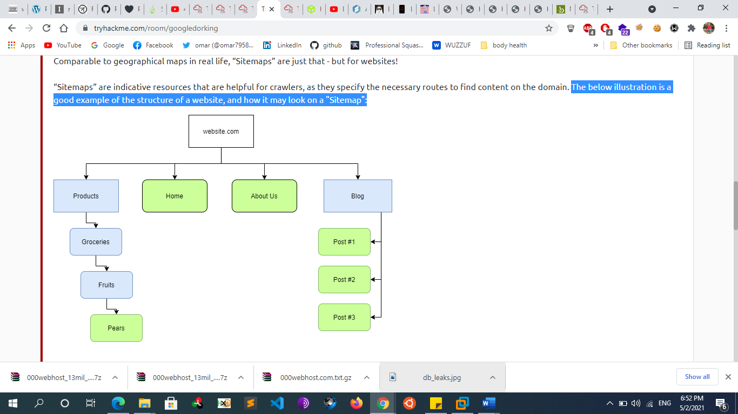

“Sitemaps” don't look like this in the real world. They look something much more similar to this:

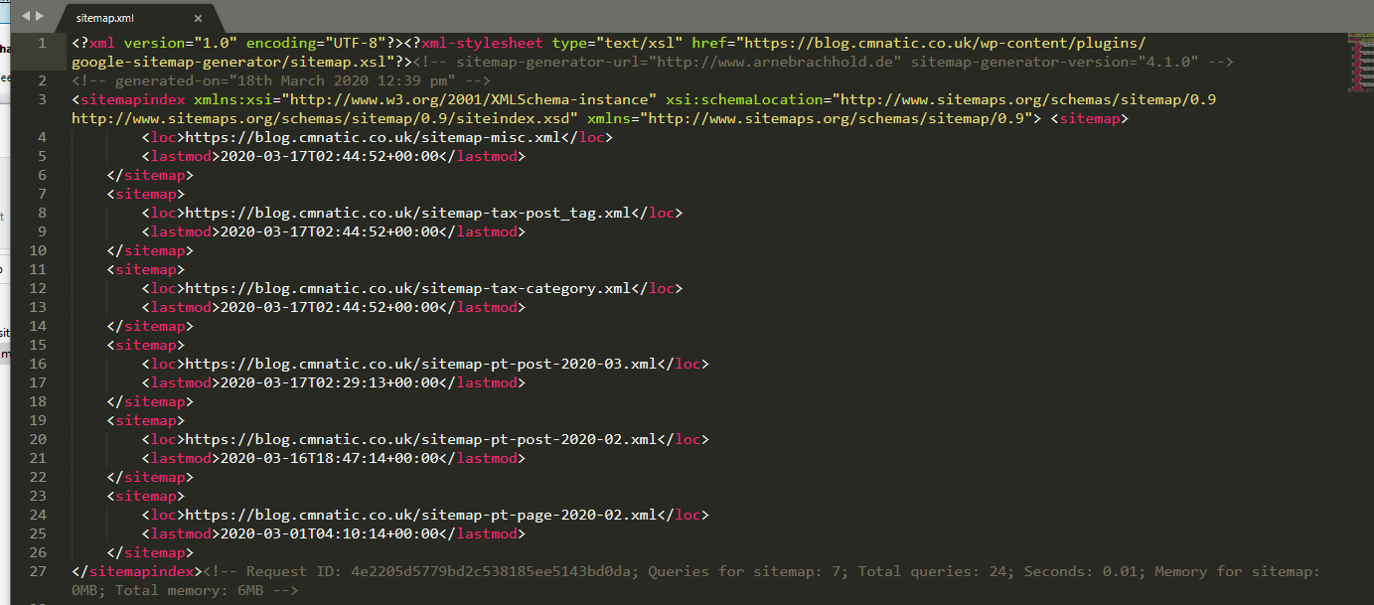

The presence of "Sitemaps" holds a fair amount of weight in influencing the "optimization" and favorability of a website. As we discussed in the "Search Engine Optimization" task, these maps make the traversal of content much easier for the crawler!  Resources like "Sitemaps" are extremely helpful for "Crawlers" as the necessary routes to content are already provided! All the crawler has to do is scrape this content - rather than going through the process of manually finding and scraping. Think of it as using a wordlist to find files instead of randomly guessing their names!

Sitemaps aren't always available d and they're always limited to what the site wants to show you d but they can be useful starting points for further investigation.

* + - * + **Robots.txt**

The robots.txt file is used to tell web spiders how to crawl a website. To avoid having confidential information indexed and searchable, webmasters often use this file to tell spiders to avoid specific pages. This is done using the keyword Disallow.

As an attacker, it's always a good idea to check the content of the robots.txt file and visit all the pages that are "disallowed" to find sensitive information

Example:

user-agent: \* Disallow: /page.php

This means disallow indexing for this page for all user-agents

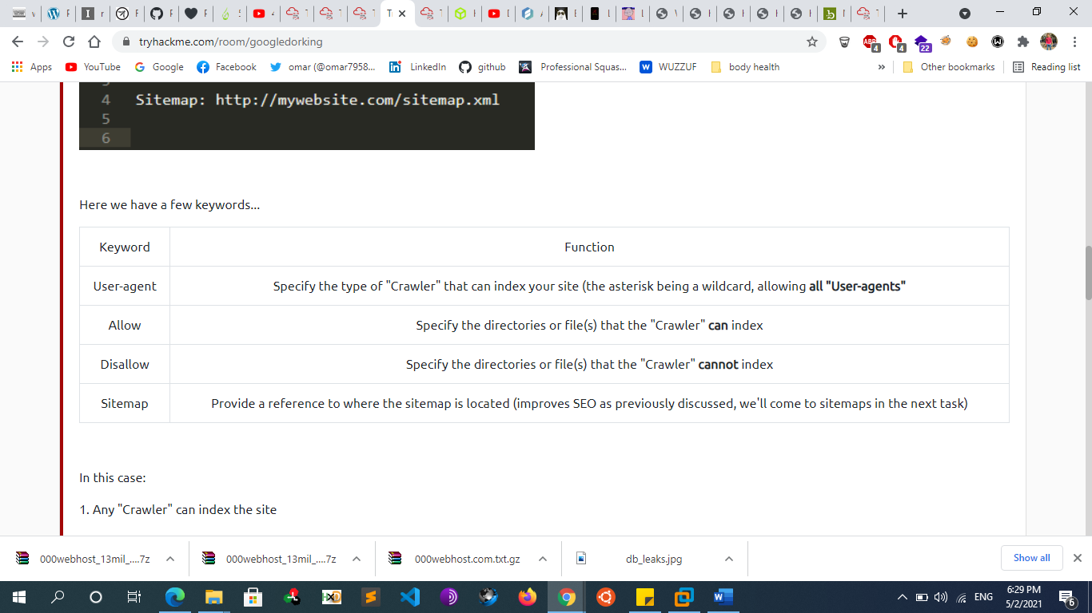

* + - * + **Others**

1- robots.txt: The robots.txt file is used to tell web spiders how to crawl a website. To avoid having confidential information indexed and searchable, webmasters often use this file to tell spiders to avoid specific pages. This is done using the keyword Disallow

2- 404 pages: Not Found/404 pages can leak information about the web stack used by a company or application. It also allows you to detect files that exists when you start bruteforcing directory. This is why it is important to check what the 404 page looks like.

3- security.txt: is a proposed standard for websites' security information that is meant to allow security researchers to easily report security vulnerabilities.The standard prescribes a text file called "security.txt" in the well known location ".well-known/security.txt", similar in syntax to robots.txt but intended to be read by humans wishing to contact a website's owner about security issues. security.txt files have been adopted by Google, GitHub, LinkedIn, and Facebook.

* + - * + **Locating Administration Consoles**

Web servers often ship with remote administration web applications, or consoles, which are accessible via a particular URL and often listening on a specific TCP port. Two common examples are the manager application for Tomcat and phpMyAdmin for MySQL hosted at /manager/html and /phpmyadmin respectively.

* + - * **Automatic Crawling:**
        + **Proxy Scanners**

burp spider or zap, webscarab

Crawling in Burp

Add to Scope the URL that You want

(can be one domain or multiple domains)

Right click on the target in sitemap

Click on Scan > Choose Crawl

Click on Scan Configuration on the Left > Choose on library > and choose the best configuration that suit you

“Crawl Strategy - Faster” is good

“Never Stop Crawl due to application errors”

Then Start

Extra Step

Before starting you can go to Resource Pool > give it a name and make it 50 for maximum concurrent requests

* + - * + **Metasploit**

use auxiliary/crawler/msfcrawler

msf auxiliary(msfcrawler) > set rhosts www.example.com

msf auxiliary(msfcrawler) > exploit

* + - **Directory Brute forcing**
      * **Wfuzz**
        + wfuzz -w ~/Code/SecLists/Discovery/Web-Content/SVNDigger/all.txt --hc 404 http://webscantest.com/FUZZ
        + python wfuzz.py -c -z file,wordlist/general/big.txt --hc 404 http://vulnerable/FUZZ

-c to output with colors.

-z file,wordlist/general/big.txt tells wfuzz to use the file wordlists/general/big.txt as a dictionary to brute force the remote directories' name.

--hc 404 tells wfuzz to ignore the response if the response code is 404 (Page not Found)

http://vulnerable/FUZZ tells wfuzz to replace the word FUZZ in the URL by each value found in the dictionary.

* + - * + wfuzz -c -w /usr/share/wfuzz/wordlist/general/megabeast.txt $ip:60080/?FUZZ=test
        + wfuzz -c --hw 114 -w /usr/share/wfuzz/wordlist/general/megabeast.txt $ip:60080/?page=FUZZ
        + wfuzz -c -w /usr/share/wfuzz/wordlist/general/common.txt "$ip:60080/?page=mailer&mail=FUZZ"
      * **ffuf**
        + apt install golang
        + git clone <https://github.com/ffuf/ffuf.git>
        + ffuf -w /usr/share/wordlists/dirbuster/directory-list.txt -u https//:target/FUZZ ->by using FUZZ keyword
      * **Dirsearch**
        + git clone <https://github.com/maurosoria/dirsearch.git>
        + ./dirsearch.py -u <http://testphp.vulnweb.com/>
        + **./dirsearch.py -u** [**[website]**](http://hostname.com) **-e php,html –x 400,401,403,404**
        + ./dirsearch.py -u [[website]](http://hostname.com) -e {aspx,php,…}
        + ./dirsearch.py -u [[website]](http://hostname.com) -e php –r

-> run recursively

* + - * + ./dirsearch.py -u [[website]](http://hostname.com) -e php,html –x 403,404 –r

-> exclude certain http response code

* + - * + ./dirsearch.py -u http://testphp.vulnweb.com/ -s 10

-s : delay between every request

* + - * + Output format

./dirsearch.py -u http://testphp.vulnweb.com/ --simple-report=report

./dirsearch.py -u http://testphp.vulnweb.com/ --plain-text-report=report

./dirsearch.py -u http://testphp.vulnweb.com/ --json-report=report

./dirsearch.py -u http://testphp.vulnweb.com/ --xml-report=report

./dirsearch.py -u http://testphp.vulnweb.com/ --markdown-report=report

./dirsearch.py -u http://testphp.vulnweb.com/ --csv-report=report

* + - * + ./dirsearch.py -u http://testphp.vulnweb.com/ -q

-q : remove unnecessarily banners

* + - * + ./dirsearch.py -u http://testphp.vulnweb.com/ -m HEAD

Change request method

* + - * **Dirbuster**
        + DirBuster is a file/directory brute-forcer. It's written in Java and programmed by the members of the OWASP community. It's a GUI application and comes with Kali Linux. DirBuster supports multithreading and is capable of brute-forcing targets at insane speeds.
        + https://www.hackingarticles.in/comprehensive-guide-on-dirbuster-tool/
      * **Gobuster**
        + Download

apt-get install gobuster

Dirbuster has a "dir" mode that allows the user to enumerate website directories. This is useful when you are performing a penetration test and would like to see what the directory structure of a website is

* + - * + gobuster dir -w /usr/share/wordlists/dirb/common.txt -u [ip]

**-o option : save result in a file**

**-e option** provides a more significant result, as it Prints complete URL when extracting any file or directories

**-r : follow redirection**

**-n Option** “no status” mode, it prints the output of the results without displaying the status code.

**-l option** enables content-length parameter which displays the size of the response. A Content-Length header is a number denoting and the exact byte length of the HTTP body for extracted file or directory.

* + - * + Gobuster dir -u [ip] -w /usr/share/wordlists/dirb/common.txt -x .php,.html

searches the given extension files

* + - * + gobuster dir -u [ip] -w /usr/share/wordlists/dirb/common.txt -q

quiet mode : disable banner

* + - * + gobuster dir -u [ip] -w /usr/share/wordlists/dirb/common.txt -a Mozilla/5.0 -fw

-a : specify a user agent

* + - * + gobuster dir -u [ip] -w /usr/share/wordlists/dirb/common.txt -s 200,301

show responses from these status codes

* + - * + gobuster dir -u [ip] dvwa -w /usr/share/wordlists/dirb/common.txt -f

appending a forward slash

* + - * + gobuster dir -u [ip] -w /usr/share/wordlists/dirb/common.txt -U test -P test

HTTP AUTHORIZATION Basic (-u username: password)

* + - * + gobuster dir -u http://192.168.1.108/ -w /usr/share/wordlists/dirb/common.txt –p 192.168.1.108:3129

use proxy

* + - * + **Gather subdomains**

the "dns" mode. This allows Gobuster to brute-force subdomains.

gobuster -m dns -u google.com -w /usr/share/wordlists/dirb/common.txt

-t [nb]: set threads number

**-fw option** to enable force processing parameter to continue the attack even if there is any Wildcard Domain

gobuster -m dns -u google.com -t 100 -w /usr/share/wordlists/dirb/common.txt -i

show subdomains with their ip

-cn : show their cname

* + - * **Dirb**
        + Dirb[http://example.com](http://INSERTIPADDRESS)
        + dirb [http://example.com](http://INSERTIPADDRESS) -r -o output.txt

-r : not recursive

The dirb scan, by default, scans the directories recursively. It means it scans a directory and then traverses inside that directory to scan for more subdirectories.

* + - * + dirb http://192.168.1.106/dvwa/ -X .php

searches the given extension files

* + - * + dirb http://192.168.1.106/dvwa/ -N 302

Ignore Unnecessary Status-Code

* + - * + dirb http://192.168.1.106/dvwa -z  100

there is some environment that cannot handle the flood created by the dirb scan, so it is important that we delay the scan for some time. -z : the time is provided on the scale of milliseconds

* + - * + dirb http://testphp.vulnweb.com/login.php -u  test:test

HTTP AUTHORIZATION Basic (-u username: password)

* + - * + dirb http://192.168.1.106/dvwa -H .php

**–H parameter** with specific extension, for example .php along with target URL it will enumerate all files or directories named with php

* + - * + dirb http://192.168.1.105/bwapp/portal.php -t

in order to run the dirb tool, we will have to add a forward slash (/) at the end of the URL to be accepted in dirb. In order to check that we need to try one attack on URL ending without any forward slash.

dirb http://192.168.1.105/bwapp/portal.php

You will observe that the scan doesn’t get executed successfully because of the lack of the forward slash, Try this attack once again with the same command with some changes so in order to run that command we have to add –t in the previous command.

* + - * + dirb http://192.168.1.108 –p 192.168.1.108:3129

-p : proxy

* + - * **Metasploit**
        + use auxiliary/scanner/http/brute\_dirs
        + use auxiliary/scanner/http/dir\_scanner
      * **Notes**
        + collect and filter all the results to show only 2xx, 3xx, 403 response codes from the tool itself (use -h to know how to filter the results) collect all these information into text file hidden\_directories.txt and try to discover the leakage data or the forbidden pages and try to bypass them
        + If you find a .git file some information can be extracted
        + If you find a .env information such as api keys, dbs passwords and other information can be found.
        + **403 Forbidden/Basic Authentication/401 Unauthorized (bypass)**

Manually

1. GET site.com => redirecting to site.com/login

2. GET site.com/login => 403

3. GET site.com //login => 200

using httpx:

cat hosts.txt | httpx -path /login -p 80,443,8080,8443 -mc 401,403 -silent -t 300 | unfurl format %s://%d | httpx -path //login -mc 200 -t 300 -nc -silent

* + - * + **Parameter discovery (discover new parameters)**

You can use tools like Arjun, parameth, x8 and Param Miner to discover hidden parameters. If you can, you could try to search hidden parameters on each executable web file.

Parameth [https://github.com/maK-/parameth]

Arjun [https://github.com/s0md3v/Arjun]

Param-miner burp

Paramspider

Python3 paramspider.py --domain domain.com --exclude svg,js,css,jpg --output domainParam.txt

Waybackurl

Cat subdomains.txt | waybackurls | grep “=” | tee -a domain\_params.txt

Wordlists

Arjun all default wordlists:

https://github.com/s0md3v/Arjun/tree/master/arjun/db\_\_

Param-miner “params” :

https://github.com/PortSwigger/param-miner/blob/master/resources/params\_\_

Assetnote “parameters\_top\_1m”:

https://wordlists.assetnote.io/\_\_

nullenc0de “params.txt”:

https://gist.github.com/nullenc0de/9cb36260207924f8e1787279a05eb773

* + - * + **Wordlists**

The quality of the wordlists you're using to brute-force-discover hidden content is important. There are many wordlists you can use here:

Jhaddix Content\_discovery\_all.txt

http://gist.github.com/jhaddix/b80ea67d85c13206125806f0828f4d10

The one(s) provided with the Tools

/usr/share/wordlists/dirb/common.txt

/usr/share/wordlists/dirb/big.txt

/usr/share/wordlists/dirbuster/directory-list-2.3-medium.txt

Seclist : Which contains several wordlists with several purposes (DNS, passwords, usernames, payloads, SQLi injection scripts, XSS snippets, and other generally malicious input,...)

<https://github.com/danielmiessler/SecLists/tree/master/Discovery/Web-Content>

raft-large-directories-lowercase.txt

directory-list-2.3-medium.txt

RobotsDisallowed/top10000.txt

Assetnote wordlists

https://github.com/carlospolop/Auto\_Wordlists/blob/main/wordlists/bf\_directories.txt

https://github.com/random-robbie/bruteforce-lists

https://github.com/google/fuzzing/tree/master/dictionaries

https://github.com/six2dez/OneListForAll

https://github.com/random-robbie/bruteforce-lists

* + - **JavaScript Analysis**
      * Another tip is always check the JavaScript code. It could be possible that you'll find new endpoints, hardcoded credentials, hardcoded JWT signing key, ... that may not be visible to the users Especially when they are making use of a CMS based on JavaScript.
      * Sometimes, Javascript files contain sensitive information including various secrets or hardcoded tokens. It’s always worth to examine JS files manually. Find following things in Javascript.
        + AWS or Other services Access keys
        + AWS S3 buckets or other data storage buckets with read/write permissions.
        + Open backup sql database endpoints
        + Open endpoints of internal services.
      * Tools to make your life easier:
        + LinkFinder
        + JSParser
        + relative-url-extractor
      * Do you need to manually put all the used JavaScript files into the tool ? Not when using BurpSuite:
        + \* In BurpSuite, Go to Target tab.
        + \* Right click on the subdomain (where you want to analyze the JS from)
        + \* Click on Engagements tools
        + \* Select Find scripts
        + \* CTRL + A to select all the scripts Burp has found.
        + \* Right click and select "Copy Selected URLS"
        + \* Paste them into a file and run a command like uniq. This to remove the duplicates.
        + \* Paste all the urls in LinkFinder/JSParser.
      * Via these tools, you can easily find new endpoints
      * **Parsing Deobfuscated JS Notes**
        + JavaScript Deobfuscator and Unpacker:

<https://lelinhtinh.github.io/de4js/>

https://matthewfl.com/unPacker.html

https://www.dcode.fr/javascript-unobfuscator

* + - * + JsFuck obfuscator / deobfuscator

(javascript with chars:"[]!+" )

<https://ooze.ninja/javascript/poisonjs/>

https://www.cleancss.com/javascript-obfuscate/index.php

http://www.jsfuck.com/

* + - * + Javascript Beautifier:

<http://jsbeautifier.org/>

http://jsnice.org/

* + - * + TrainFuck:

+72.+29.+7..+3.-67.-12.+55.+24.+3.-6.-8.-67.-23.

* + - * + In several occasions you will need to understand regular expressions used, this will be useful:

https://regex101.com/

* + - * **Notes**
        + You should also check discovered JS files with RetireJS or JSHole to find if it's vulnerable.
        + Find hidden GET parameters in javascript files

assetfinder example.com | gau | egrep -v '(.css|.png|.jpeg|.jpg|.svg|.gif|.wolf)' | while read url; do vars=$(curl -s $url | grep -Eo "var [a-zA-Z0-9]+" | sed -e 's,'var','"$url"?',g' -e 's/ //g' | grep -v '.js' | sed 's/.\*/&=xss/g'); echo -e "\e[1;33m$url\n\e[1;32m$vars"; done

* + - * + use grep to collect all js files form waybackurls.txt as cat waybackurls.txt | grep js > js\_files.txt

save all the results to js\_files.txt

* + - * + you can analyze these files manually or use automation tools (I recommend manual scan, see references)
    - **Virtual hosts scanning (Discovery)**
      * **FFUF**
        + ffuf -w /usr/share/wordlists/wfuzz/general/common.txt -u https://hackycorp.com/ -H "Host: FUZZ.hackycorp.com" -fs 4242
      * **Gobuster**
        + "vhost" Mode

the "vhost" mode. This allows Gobuster to brute-force virtual hosts. Virtual hosts are different websites on the same machine. In some instances, they can appear to look like sub-domains, but don't be deceived! Virtual Hosts are IP based and are running on the same server. This is not usually apparent to the end-user. On an engagement, it may be worthwhile to just run Gobuster in this mode to see if it comes up with anything. virtual hosts would be a good way to hide a completely different website if nothing turned up on your main port 80/443 scan.

* + - * + Example

gobuster vhost -u http://example.com -w /usr/share/wordlists/SecLists/Discovery/DNS/subdomains-top1million-5000.txt

This will tell Gobuster to do a virtual host scan http://example.com using the selected wordlist

vhostbrute.py --url="example.com" --remoteip="10.1.1.15" --base="www.example.com" --vhosts="vhosts\_full.list"

From https://github.com/allyshka/vhostbrute

VHostScan -t example.com

#https://github.com/codingo/VHostScan

* + - **Large Scope Reconnaissance (Asset Discovery)**
      * **Overview**
        + The First Thing in Recon Methodology is to identify our root Domains (Seeds) and this can be done by multiple Ways

Checking the Scope of the program at the Bug Bounty Platform

Acquisitions

Autonomous system number (ASN) Recon

Other Methods

Reverse Whois (Linked Discovery)

Use reverse whois lookups to search for other entries (organisation names, domains...) related to the first one (this can be done recursively)

Shodan

Fav icon Search

* + - * **Company acquisitions**
        + **We can investigate company’s acquisition on sites like**

Crunchbase

Wikipedia

Google

* + - * + **Crunchbase**

CrunchBase is a database where you can find information about organizations:

Companies

People

Investors and financial information

Companies Acquisitions

The power of CrunchBase is grounded on the concept of anyone being able to edit information in it.

We will use Crunchbase to find Company Acquisitions. Enter the the company or a person into the search bar at the top of the page and look at the acquisitions.

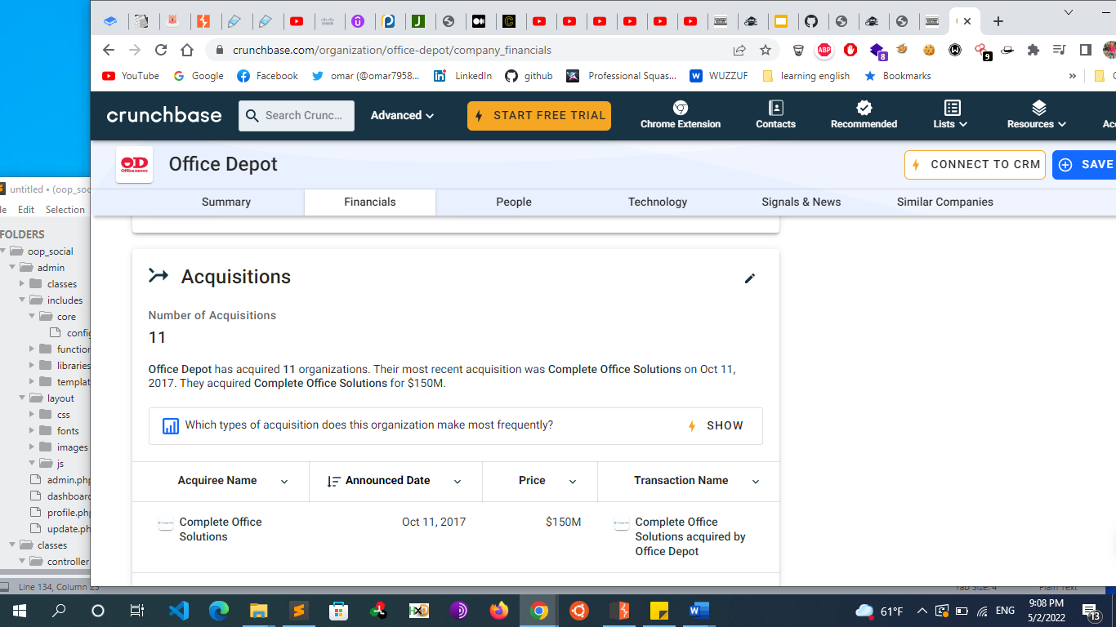

* + - * + **Wikipedia**

Other option is to visit google and the Wikipedia page of the main company and search for acquisitions.

* + - * **Autonomous system number (ASN) Recon**
        + **What is ASN**

An Autonomous System (AS) is a set of Internet routable IP prefixes belonging to a network or a collection of networks that are all managed, controlled and supervised by a single entity or organization. An AS utilizes a common routing policy controlled by the entity. The AS is assigned a globally unique 16 digit identification number known as the autonomous system number or ASN by the Internet Assigned Numbers Authority (IANA).

Autonomous System Number (ASN) is a globally unique identifier that defines a group of one or more IP prefixes run by one or more network operators that maintain a single, clearly-defined routing policy. These groups of IP prefixes are known as autonomous systems.

Autonomous systems numbered one to 64511 are available by IANA for global use. The 64512 to 65535 series is reserved for private and reserved purposes. Autonomous Systems were introduced to regulate networking organizations such as Internet Service Providers (ISP), educational institutions and government agencies.

Border Gateway Protocol (BGP) is the protocol that manages the routed peerings, prefix advertisement and routing of packets between different autonomous systems across the Internet. BGP uses the ASN to uniquely identify each system. In effect, BGP is the routing protocol for AS paths across the Internet.

* + - * + **Getting ASN numbers and IP ranges**

Using Tools

ASNLookup

<https://github.com/yassineaboukir/Asnlookup>

Which utilize maxmind.com dataset

Metabigor

<https://github.com/j3ssie/metabigor>

Which will fetch ASN data From ASNLOOKUP.com and <https://bgp.he.net/>

Online

The most reliable way to get these ASN is manually through

<https://bgp.he.net/>

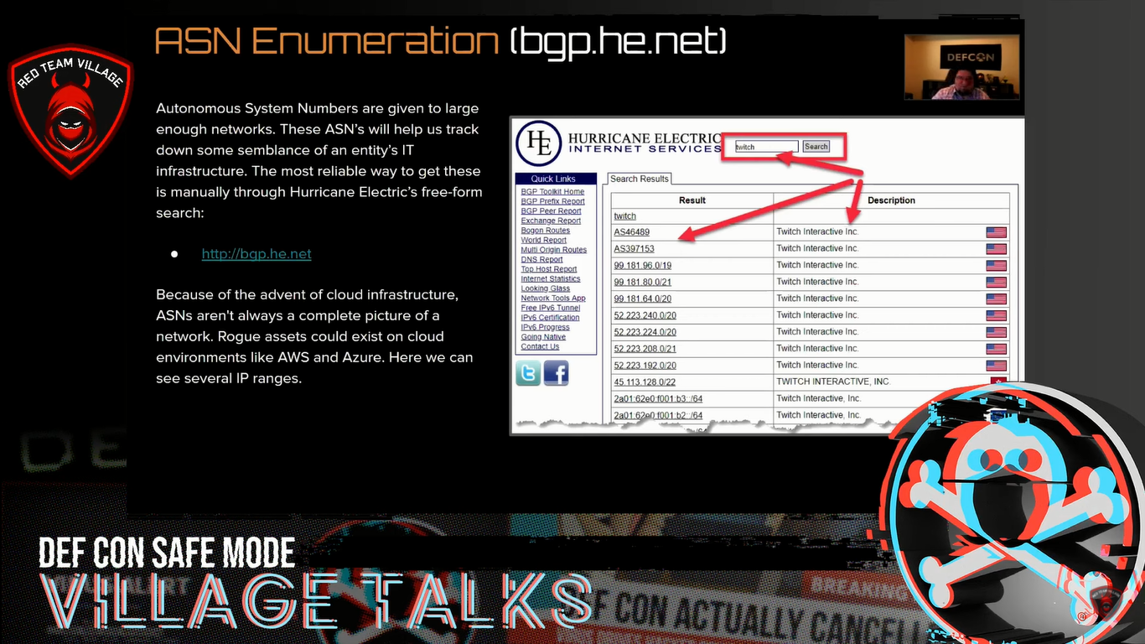

Here we got 2 ASN numbers if we clicked one of them, we will get the IP ranges of each ASN.

So after getting the Acquisitions of the company we will try to grab the ASN/IP ranges of Each one. So now we have ASN numbers and IP ranges of the Company and this is an example how can we organize what we found so far

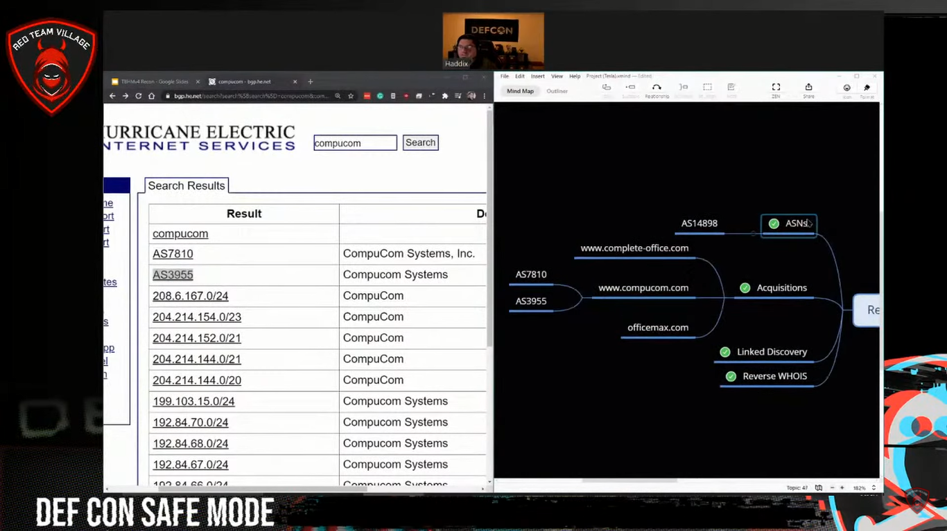

* + - * + **Getting Root/Seed Domains From ASN**

For discovering more seed domains we want to scan the whole ASN with a port scanner on return any root domains we see in SSL certficates, etc.

We can do this with Amass intel Amass is written by Jeff Foley and the amass team

Amass intel module collects open-source intelligence for the target organization. It allows you to find root domain names associated with it.

amass intel -org <org-name>

amass intel -asn <asn>

Amass Intel -asn 45646

amass intel -asn 8911,50313,394161

Example

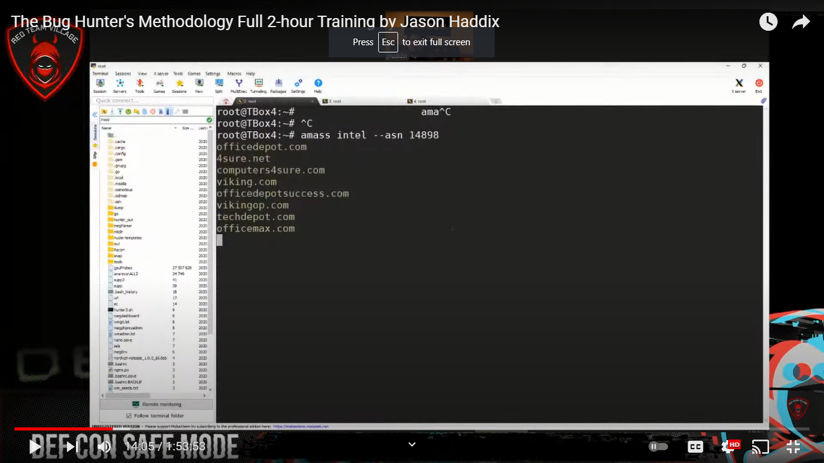

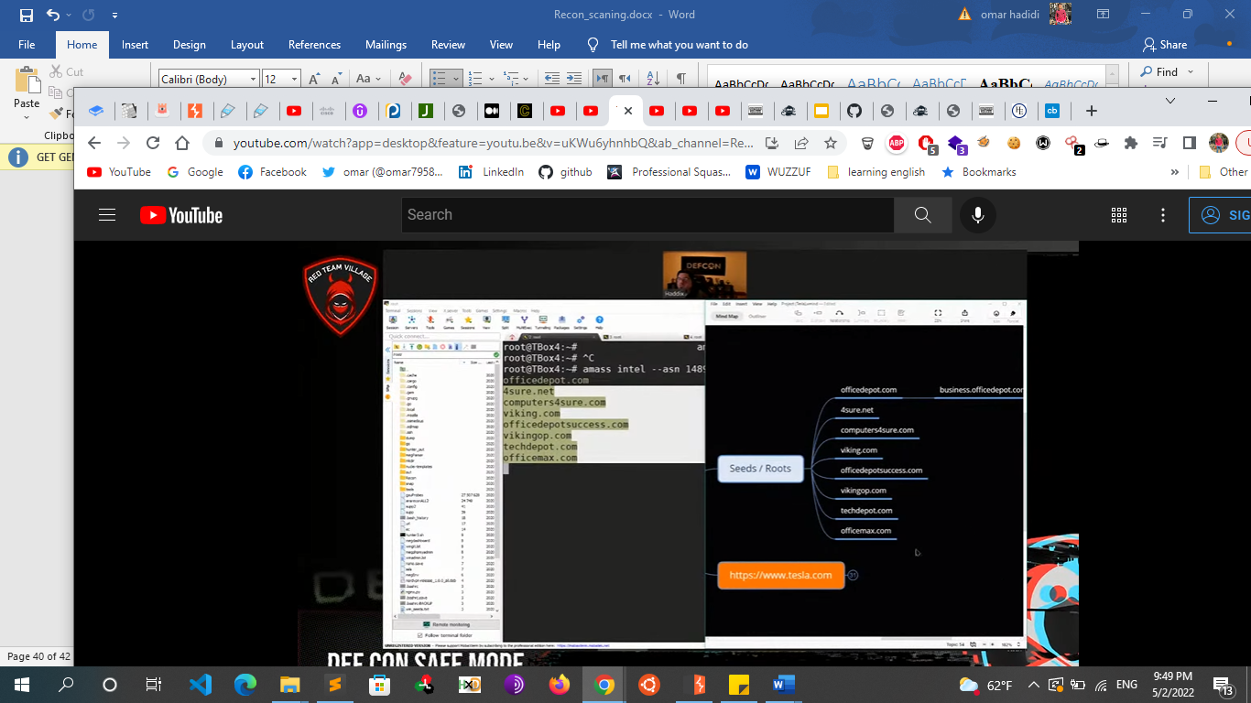

So now We have Gathered ASN numbers , IP ranges and Root Domains

* + - * + **Notes**

Note: Because of the advent of cloud infrastructure, ASNs may not provide a complete picture of a network. Assets could also exist on cloud environments like AWS, GCP, and Azure.

Bash Script

amass intel -org yahoo -max-dns-queries 2500 | awk -F, '{print $1}' ORS=',' | sed 's/,$//' | xargs -P3 -I@ -d ','

amass intel -asn @ -max-dns-queries 2500

This is what the command does in detail:

Get a list of ASNs (Autonomous System Numbers) of the target organization (e.g. yahoo)

Extract only a list of AS numbers and separate them by comma

For each identified ASN, find list of domain names that are associated with the ASN

* + - * **Other Methods**
        + **Reverse WHOIS (Linked Discovery)**

Inside a **whois** you can find a lot of interesting **information** like **organisation name**, **address**, **emails**, phone numbers... But which is even more interesting is that you can find **more assets related to the company** if you perform **reverse whois lookups by any of those fields** (for example other whois registries where the same email appears). Reverse WHOIS leverage these registries and allow us to perform lookups based on that additional information You can use online tools like:

Whoxy Whois

https://www.whoxy.com/

Reverse Whois Lookup

https://www.reversewhois.io/

DomainEye Reverse Whois

https://domaineye.com/reverse-whois

domainIQ - Comprehensive domain name intelligence.

https://www.domainiq.com/

**Automated Tools**

DomLink

you can automate this task using DomLink (requires a whoxy API key).

python domlink.py -A <whoxy-api-key> -C <org-name> -o target.out.txt

python domlink.py -d <domain.com > -o target.out.txt

Whoxy API

curl --no-progress-meter "https://api.whoxy.com/?key=<whoxy-api-key>&reverse=whois&name=<org-name>" | jq

* + - * + **Trackers (Ads/Analytics)**

If find the same ID of the same tracker in 2 different pages you can suppose that both pages are managed by the same team.

For example, if you see the same Google Analytics ID or the same Adsense ID on several pages.

There are some pages that let you search by these trackers and more:

BuiltWith

Sitesleuth

Publicwww

SpyOnWeb

* + - * + **Shodan**

Shodan is a search engine for Internet-connected devices. Try filter by organization: org:<org-name> or hostname: hostname: <domain>.

Use other techniques like shodan “org” and “ssl” filters to search for other assets (the ssl trick can be done recursively).

ssl:”trade name”

ssl:”Facebook Inc.”

* + - * + **Favicon hashes**

Did you know that we can find related domains and sub domains to our target by looking for the same favicon icon hash

A more fringe technique of discovering a brands assets is taking their favicon and hashing it. You can then take this hash and search shodan for it. You can also scan IP ranges and cloud blocks to find assets with the same hash. In addition you can make hashes of commonly used admin portals or framework logins. This method is useful when an org has modified URL paths and maybe your scanners are only looking for a specific path. If the org has changed it all you won't find it, but org's rarely change the favicon for the frameworks.

**Tools**

FavFreak by Devansh Batham (OxAsmOd3us)

cat urts. txt | python3 favfreak.py -o output

search org: "Target"

avicon.hash:116323821

port

Favihash.py

cat my\_targets.txt | xargs -I %% bash -c 'echo "http://%%/favicon.ico"' > targets.txt

python3 favihash.py -f https://target/favicon.ico -t targets.txt -s

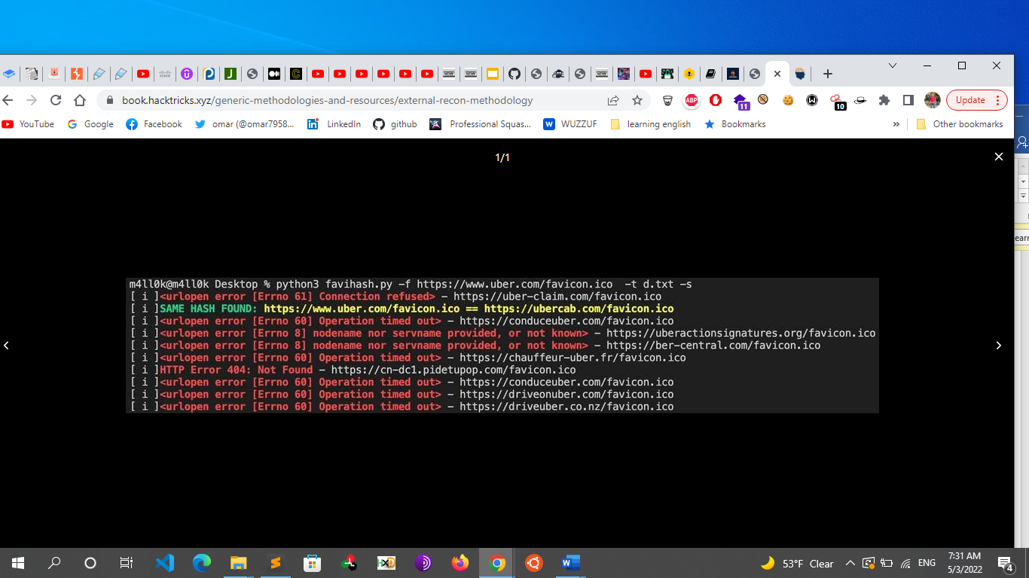

* + - * **Notes**
        + At this point we known all the assets inside the scope, so if you are allowed you could launch some vulnerability scanner (Nessus, OpenVAS) over all the hosts.
        + Also, you could launch some port scans or use services like shodan to find open ports and depending on what you find you should take a look in this book to how to pentest several possible services running.
        + Also, It could be worth it to mention that you can also prepare some default username and passwords lists and try to bruteforce services with

https://github.com/x90skysn3k/brutespray.

* + - **Others**
      * **WAF**
        + To check which WAF is used on a certain subdomain, I make use of wafwoof.
      * **GitHub Recon**
        + **Overview**

Github is also a great place to look for credentials and private API keys. The hardest thing about this method is getting creative when it comes down to looking for different keys.

GitHub Dorking uses specific search keys to find sensitive information in public repositories. This is similar to Google Dorking

while doing subdomain enumeration we can start on dorking on GitHub for some finds

* + - * + **GitHub Dorks Example**

"Company" password

"Company" secret

"Company" credentials

"Company" token

"Company" config

"Company" key

"Company" pass

"Company" login

"Company" pwd

"Company" ssh\_auth\_password

"Company" ssh\_user

"Company" ssh\_pasword

"Company" ftp

"Company" security\_credentials

"Company" connectionstring

"Company" JDBC

"Company" send\_key,send\_keys

* + - * + **You can find more GitHub dorks**

https://github.com/KathanP19/HowToHunt/blob/master/Recon/Github\_Dorking.md

<https://github.com/techgaun/github-dorks/blob/master/github-dorks.txt>

https://book.hacktricks.xyz/generic-methodologies-and-resources/external-recon-methodology/github-leaked-secrets

* + - * + **Tools**

For larger repos, we can use several tools to help automate some of the searching, such as Gitrob and Gitleaks. Recon-ng also has several modules for searching GitHub. Most of these tools require an access token to use the source code hosting provider’s API.

Gitrob

https://github.com/michenriksen/gitrob

Gitleaks

Gitdorker

<https://github.com/obheda12/GitDorker>

Github-dorks

<https://github.com/techgaun/github-dorks>

git-all-secrets

https://github.com/anshumanbh/git-all-secrets

truffleHog

https://github.com/dxa4481/truffleHog

git-secrets

https://github.com/awslabs/git-secrets

github-dorks

https://github.com/techgaun/github-dorks

gitGraber

https://github.com/hisxo/gitGraber

gittyleaks

https://github.com/kootenpv/gittyleaks

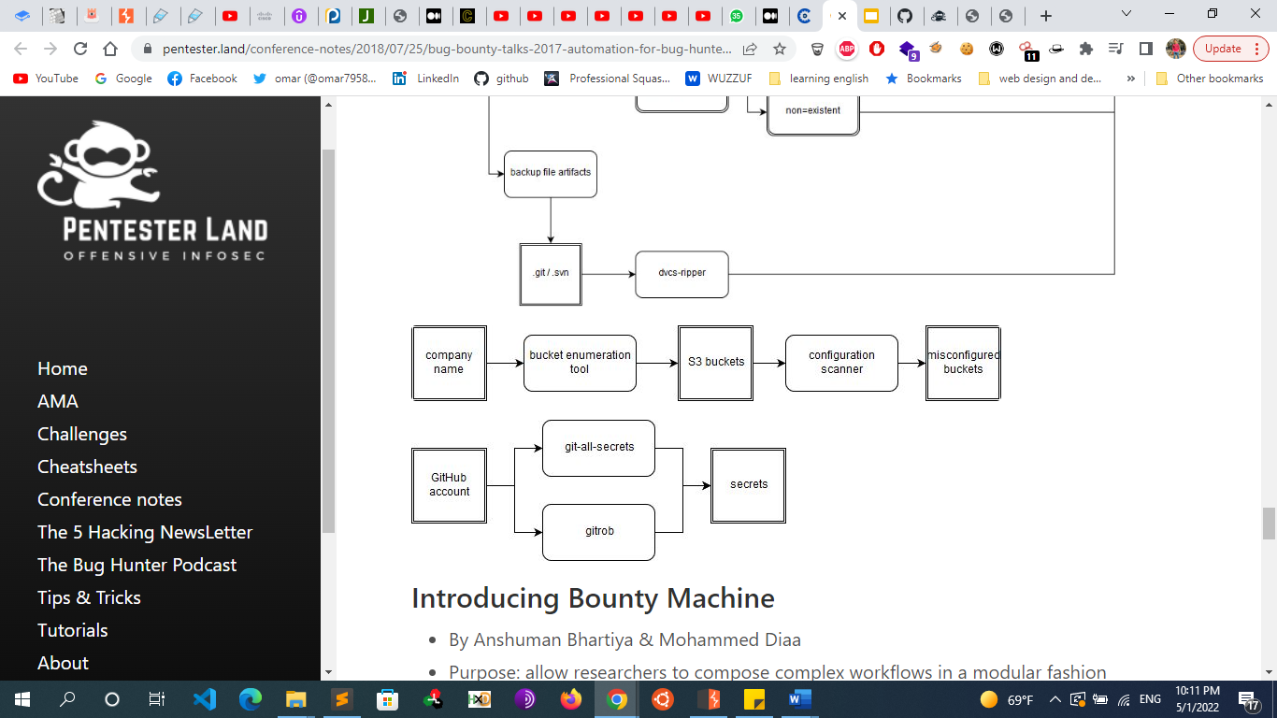

* + - * + **Notes**

You can also search for leaked secrets in all open repository platforms using: https://searchcode.com/?q=auth\_key

* + - * **S3 Buckets Leaks**
        + AWS has become a huge asset to thousands of different companies. Some companies just use AWS s3 buckets to host their content, while others use it to deploy and host their application. Like any other resource, AWS could also be misconfigured or abused by criminals. For example, it's often possible to find misconfigured s3 buckets that allow a user outside of the organization to read and write files on a bucket belonging to that company.
        + These properties can be discovered by combining a few different methods:

Using a google dork to find them: site:s3.amazonaws.com + hackme.tld

We can look them up on github: “hackme.tld” + “s3”

We can bruteforce AWS to find specific s3 buckets and automate this to speed it up

* + - * + 
        + Note

Amazon Web Services Storage Service (S3) allows file owners to set permissions on files. Historically, the rules "Any users" wasn't well explained and lead a lot of people to think only people in their Amazon account could access a file. However, this was allowing any AWS account to access the file

* + - * + Tools

Awscli

AWS CLI is useful for verifying or testing the permissions of the AWS S3 buckets, Creating Buckets and Read other buckets data. AWS Account needed to use CLI

apt install awscli

aws configure (paste your Access key and secret key)

aws s3 ls s3://assets.hackycorp.com/key2.txt

aws s3 cp s3://assets.hackycorp.com/key2.txt key2.txt

Lazys3

<https://github.com/nahamsec/lazys3>

LazyS3 is another tool which I use almost frequently to find the staging, sandboxed, dev and production buckets.

sandcastle [https://github.com/0xSearches/sandcastle]

slurp

S3scanner

teh\_s3\_bucketeer

* + - * + dork

site:s3.amazonaws.com inurl:site

* + - * + note

Another tip it's not because a bucket is not publicly readable that the permissions to write or delete a file into/from the bucket are correctly configured. Always test writing into the bucket.

https://book.hacktricks.xyz/network-services-pentesting/pentesting-web/buckets

* + - * **Subdomain Takeover**
        + When you have a main list of all the subdomains, you can start looking for subdomain takeovers. You can provide your list of subdomains to a tool like [SubOver](https://github.com/Ice3man543/SubOver). I highly recommended resource is <https://github.com/EdOverflow/can-i-take-over-xyz>. In here you'll find the default messages provided by several services which can lead to a subdomain takeover.
        + **subdomain takeover tools**

When you are using **aquatone**, you can use **aquatone-takeover**.

<https://github.com/m4ll0k/takeover>

Subjack

https://github.com/haccer/subjack

Nuclei

Nuclei -l live\_subdomains.txt -t subdomain-takeover/\*

* + - **Frameworks & Automated tools**
      * Frameworks
      * If could be recon is not really your thing. That's all right.
      * Several hunters have open sourced their automation at this point and you can choose one that fits you and use it without worrying too much. I usually classify recon frameworks in rough tiers:
        + C-Tier: automation built around scripting up other tools in bash or python. Step based, no workflow.

Few techniques. Little extensibility.

* + - * + B-Tier: automation writing a few of their own modules. Some GUl or advanced workflow. Medium number of techniques. Runs point-in-time. Flat files.
        + A-Tier: (maybe) automation writing all their own modules. Has GUI. Runs iterativley. Manages data via db.
        + S-Tier: automation writing their own modules. Has GUI. Runs iterativley. Manages data via db. Scales across multiple boxes. Sends alerts to user. Uses novel techniques and iterates quickly. ML + Al.
      * There are several tools out there that will perform part of the proposed actions against a given scope.
        + C-Tier

https://github.com/AdmiralGaust/bountyRecon

https://github.com/offhourscoding/recon

https://github.com/Sambal0x/Recon-tools

https://github.com/JoshuaMart/AutoRecon

https://github.com/yourbuddy25/Hunter

https://github.com/venom26/recon/blob/master/ultimate\_recon.sh

https://gist.github.com/dwisiswant0/5f647e3d406b5e9

84e6d69d3538968cd

* + - * + B-Tier

https://github.com/capt-meelo/LazyRecon

is a tool written by naham sec that combine many recon tools in one tool

https://github.com/Screetsec/Sudomy

https://github.com/phspade/Automated-Scanner

https://github.com/devanshbatham/Gorecon

https://github.com/shmilylty/OneForAll https://github.com/LordNeoStark/tugarecon

https://github.com/SolomonSklash/chomp-scan

https://github.com/TypeError/domained

* + - * + A-Tier

https://github.com/Edu4rdSHL/findomain

https://github.com/SilverPoision/Rock-ON

https://github.com/epi052/recon-pipeline

* + - * + S-Tier

[**https://github.com/yogeshojha/rengine**](https://github.com/yogeshojha/rengine)

https://github.com/j3ssie/Osmedeus

hunterSuite.io

Jaeles

Intrigue.io

AssetNote

* + - **Resources**
      * **Videos**
        + https://m.youtube.com/watch?v=YhUiAH5SIqk

Naham sec building ubuntu box

* + - * + https://www.youtube.com/watch?v=l8iXMgk2nnY&ab\_channel=ST%C3%96K

stok: linux terminal tools for bug bounty pentest and redteams with @tomnomnom

* + - * + https://www.youtube.com/playlist?list=PLKAaMVNxvLmAkqBkzFaOxqs3L66z2n8LA

naham sec recon sunday

* + - * + https://m.youtube.com/watch?feature=youtu.be&v=uKWu6yhnhbQ

The Bug Hunter's Methodology Full 2-hour Training by Jason Haddix

* + - * + https://m.youtube.com/watch?feature=youtu.be&v=gIz\_yn0Uvb8

The Bug Hunter's Methodology by Jason Haddix 4.02

* + - * + https://www.youtube.com/watch?v=p4JgIu1mceI&ab\_channel=Nahamsec

The Bug Hunter's Methodology by Jason Haddix 4.0 (Nahamsec Channel)

* + - * + https://youtu.be/Qw1nNPiH\_Go

LevelUp 0x02 - Bug Bounty Hunter Methodology v3 2018

* + - * + https://youtu.be/VtFuAH19Qz0

How To Shot Web - Jason Haddix's talk from DEFCON23 2015

* + - * + <https://securib.ee/beelog/the-best-bug-bounty-recon-methodology/>

Multiple videos

* + - * **Blogs**
        + <https://pentester.land/cheatsheets/2019/04/15/recon-resources.html>
        + <https://infosecwriteups.com/recon-methodology-for-bug-hunting-e623120a7ca6>
        + <https://medium.com/soulsecteam/advanced-recon-automation-subdomains-case-1-9ffc4baebf70>
        + <https://systemweakness.com/simple-recon-methodology-a9ff080b40c8>
        + <https://book.hacktricks.xyz/generic-methodologies-and-resources/external-recon-methodology>
        + https://book.hacktricks.xyz/network-services-pentesting/pentesting-web
        + <https://github.com/Quikko/Recon-Methodology>
        + https://www.hackerone.com/ethical-hacker/how-recon-and-content-discovery
        + https://orwaatyat.medium.com/my-methodology-in-recon-and-find-bugs-my-methodology-in-hunting-using-phone-ccc9fe06dd2d
        + https://pentester.land/conference-notes/2018/07/25/bug-bounty-talks-2017-automation-for-bug-hunters.html
        + <https://gist.github.com/cyberheartmi9/1ac77d171d9b9dc9a5be45fa4f4c8dcb>
        + https://docs.google.com/presentation/d/1PCnjzCeklOeGMoWiE2IUzlRGOBxNp8K5hLQuvBNzrFY/edit#slide=id.g129ec7274d\_1\_381
        + <https://speakerdeck.com/e11i0t_4lders0n/the-bug-hunters-recon-methodology?slide=11>
        + https://mavericknerd.github.io/knowledgebase/BugBountyRecon/
        + https://gowthams.gitbook.io/bughunter-handbook/list-of-vulnerabilities-bugs/recon-and-osint/recon
  + **SSL scanning**
    - **Sslyze**
      * sslyze --regular [www.example.com](http://www.example.com)
    - **Sslscan** 
      * Sslscan [website]
    - **Nmap** 
      * nmap --script ssl-enum-ciphers -p [port] [hostname]
    - **tls-scan** 
      * tls-scan -c [[website]](http://search.yahoo.com) --all --pretty
    - **Testssl.sh**
      * git clone –depth 1 <https://github.com/drwetter/testssl.sh.git>
      * ./testssl.sh [website]
    - [**https://pentest-tools.com/network-vulnerability-scanning/ssl-tls-scanner**](https://pentest-tools.com/network-vulnerability-scanning/ssl-tls-scanner)
    - **Ssllabs.com**